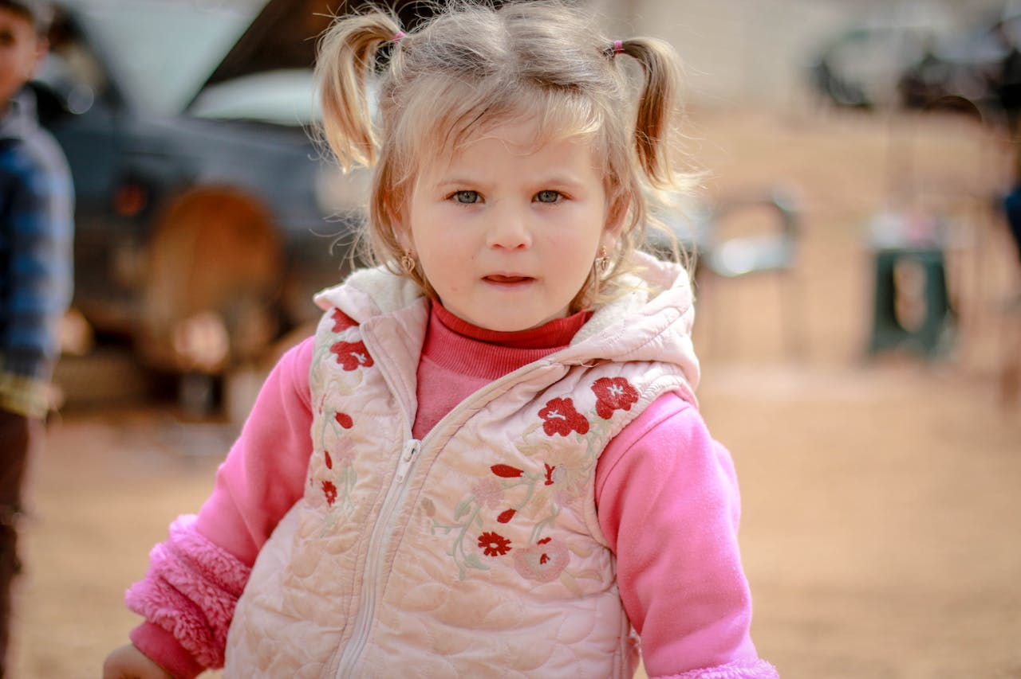


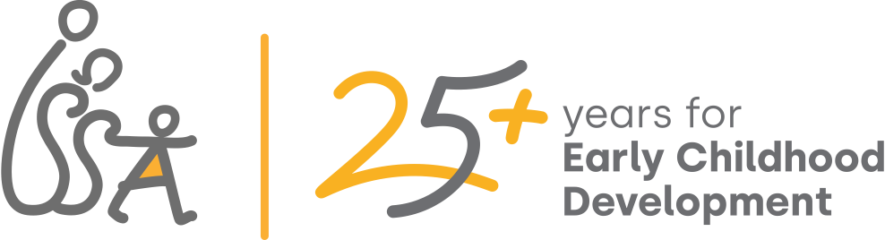
A Compendium of ISSA Network Contributions to System Preparedness in Emergency Contexts

November 2025
Prepared Early Childhood Systems That Stand by Every Child, in Every Crisis
Published by the ISSA Network
Authors
Ayça Alaylı, Programme Manager, (ISSA)
Francesca Colombo, Programme Manager (ISSA)
Mihaela Ionescu, PhD (ISSA)


International Step by Step Association (ISSA)
Kinderrechtenhuis / Child Rights Home
Hooglandse Kerkgracht 17-R
2312 HS Leiden
T333he Netherlands
Tel: +31 (0)71 516 1222
Acknowledgments
With gratitude to the ISSA members who contributed their experiences, learnings, and recommendations to this publication, including Trust for Social Achievement, Worldwide Foundation for Vulnerable Children , Partners Hungary Foundation, Step by Step Center for Education and Professional Development , Comenius Foundation for Child Development
International Child Development Initiatives, Mother-Child Education foundation – AÇEV, Ukrainian Step by Step Foundation, Transcarpathian Regional Charitable Fund Blaho, Step by Step Educational Program Moldova, Step by Step Czech Republic, Step by Step Albania, Amna Refugee Healing Network, AMURTEL, For Our Children Foundation, Step by Step Center for Education and Professional Development, ASAM, Ukrainian Step by Step Foundation, Amna Refugee Healing Network and Center for Interactive Pedagogy and to Early Childhood Regional Networks Fund for their financial support to produce this publication.

Foreword
A few words before reading this Compendium….
The early years of life are the foundation upon which all future development, learning, health, and well-being are built. Yet, these critical years are increasingly threatened by crises—natural disasters, conflicts, pandemics, and economic shocks that disrupt family life, fracture communities, and strain systems. For young children, the consequences can be profound and lasting. Interruptions in access to health, nutrition, care, and early learning undermine developmental progress at a time when it matters most.
Preparedness is not optional. It is an ethical imperative. Early Childhood Systems must be ready to act before, during, and after crises to ensure continuity of services and protection particularly for the most vulnerable. Being prepared does not only mean having emergency protocols; it means building resilient systems that can anticipate, adapt, and recover—systems that place children and families at the centre of response and recovery strategies.
This compendium presents a framework for Early Childhood System Preparedness, organized around five interdependent components. Each represents a crucial pillar of resilience and sustainability:
- Emergency Response – The ability to mobilize quickly and effectively in the face of disruptions, ensuring that essential services for young children and families remain accessible.
- Flexible Service Delivery – The capacity to adapt and innovate in service models, locations, and modalities, so that quality support reaches every child, even in unstable contexts.
- Workforce Capacity and Well-being – Strengthening the competence, resilience, and mental health of the early childhood workforce, recognizing them as the backbone of quality service delivery and system continuity.
- Integrated Mental Health and Psychosocial Support (MHPSS) – Embedding mental health and psychosocial care in early childhood services to safeguard emotional well-being and resilience for children, families, and practitioners.
- Governance, Coordination, and Accountability – Establishing strong leadership, aligned policies, and transparent mechanisms for cross-sectoral collaboration, ensuring coherent, equitable, and effective responses.

These components do not operate in isolation. Their true power lies in integration—when emergency response is guided by robust governance, when flexible services are enabled by a skilled and supported workforce, and when mental health is treated as essential to child development. Together, they create systems that can withstand shocks, maintain equity, and emerge stronger from adversity.
As you explore this compendium, we invite you to see preparedness not as a technical exercise, but as a collective commitment to uphold the rights and potential of every young child, in every circumstance. Resilient systems are not built overnight; they are the product of foresight, collaboration, and unwavering dedication. Let this resource guide and inspire action toward that goal—because when systems are prepared, children have the chance to thrive, no matter what challenges the world presents.


Table of Contents

Foreword 4
Introduction 8
The Early Childhood System on Good Days and in Emergencies 10
The Early Childhood System on a Good Day 10
Core Elements of the Early Childhood System 10
Key Actors in ECD Systems at country level 12
Common Risk Factors for Young Children and Families in Emergencies 13
Disruption of Caregiving and Attachment Relationships 13
Food Insecurity and Malnutrition 14
Heightened Risk of Violence, Neglect, Exploitation 14
Interrupted Access to Essential Services 14
Psychosocial Distress and Toxic Stress Exposure 14
Unsafe Living Conditions 15
Core Components of Early Childhood System Preparedness for Emergencies 16
Emergency response 16
Flexible service delivery 16
Workforce capacity and well-being 17
Integrated mental health and psychosocial support (MHPSS) 17
Governance, coordination, and accountability 17
ISSA’s Journey in Preparedness and Response to Emergencies 19
Emergency response 19
Emergency support to Roma families from Transcarpathia fleeing to Hungary 20
Supporting vulnerable young children and families during COVID-19 23
Advocacy efforts for an inclusive early childhood system 27
Flexible service delivery 29
SPYNKA Program 30
Creating safe learning environments to counter war disruption 33
TOY4Inclusion 35
Mobile units bring ECD services to undeserved areas 38
Station of Hope shelter and learning centre 41
Workforce capacity and well-being 43
Online training for public school teachers 43
Training teaching assistants to work with Ukrainian children in schools and kindergartens 45
Psychological First Aid Learning Community 48
Blended learning and holistic teacher support for equitable ECEC during COVID-19 50
Staff well-being and retention | Pandemic | Step by Step Albania, Albania 50
Integrated mental health and psychosocial support 51
Building Resilience Through Healing and Play 52
Psychological First Aid cascade training 54
Baytna trauma- and identity-informed activities during COVID-19 56
Community-based hubs for learning and psychosocial support 58
Psychological First Aid and Therapeutic Storytelling 61
Governance, coordination, and accountability 62
Prioritising Young Children’s Development Through Multi-Sector Action 63
Measuring impact in time of crisis 65
Program for empowerment and promoting the development of competencies of parents of children up to 12 years of age, in situations of migrations and refugeehood (PoM) 67
Measuring impact in time of crisis 69
Conclusion 72
Appendix 73
Common Elements of Early Childhood System Preparedness Across Emergencies 73
Distinct Actions by Emergency Type 74

Introduction
Crises—whether caused by conflict, displacement, natural disasters, or pandemics—disrupt the lives of young children and families, often with lasting consequences. The Early Childhood Development in Emergencies (ECDiE) Compendium brings together lessons and practices from ISSA members who have worked across diverse emergency contexts, showcasing how early childhood systems can prepare for, withstand, and recover from such disruptions. It underscores a central message: resilience is not built through isolated interventions, but through coordinated, adaptive systems that can sustain services and support for young children and their families—before, during, and after a crisis.
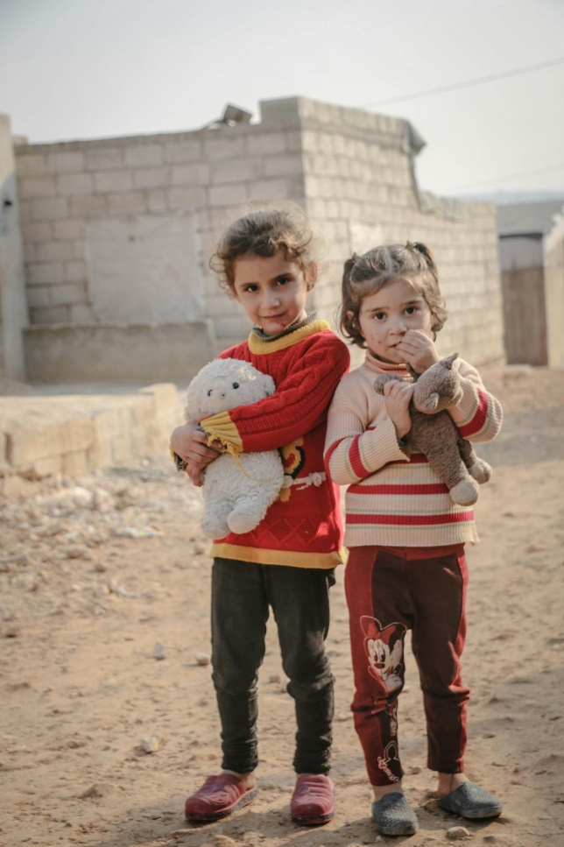
The Compendium is organized into two main sections. The first, Early Childhood Systems on Good Days and in Emergencies, explores what preparedness means for early childhood development—outlining the essential components of systems that can anticipate, respond to, and recover from disruptions while continuing to serve young children and families. The second, ISSA’s Journey in Preparedness and Response to Emergencies, illustrates these principles in action, sharing real examples from ISSA members who have adapted their programs and partnerships to ensure continuity of care, learning, and protection for children in times of crisis.
Together, these sections offer both a framework and lived evidence of how preparedness can be embedded within early childhood systems. They highlight the importance of building coordinated, flexible, and inclusive structures capable of ensuring that every child—especially the most vulnerable—has access to quality care and early learning, no matter the circumstances. The ECDiE Compendium aims to inform reflection, inspire collaboration, and strengthen the collective capacity of the early childhood field to protect and nurture children when they need it most.



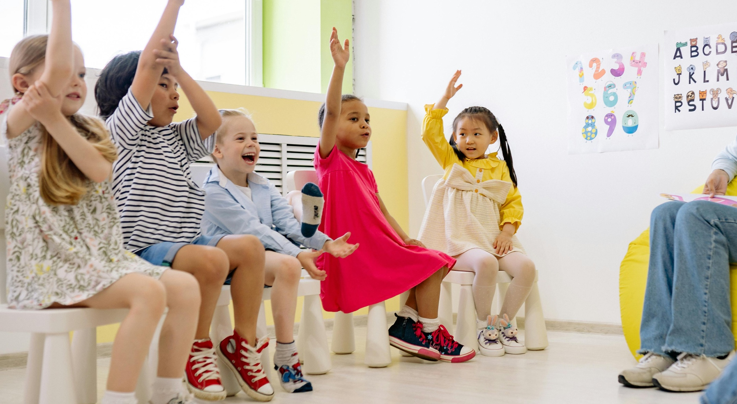

The Early Childhood System on Good Days and in Emergencies

The Early Childhood System on Good Days and in Emergencies

The Early Childhood System on a Good Day
It takes an entire system working together to secure a bright future for young children. Early childhood systems are complex and require a comprehensive view on the constellation of services, policies, actors and mechanisms in formal, non-formal and informal settings that ensure its effective functioning for the highest benefit of every young child, wherever they are born, live and develop. To better understand how such systems operate, the following sections outline the core elements that make up a strong Early Childhood System and the key actors whose collaboration brings it to life.

Core Elements of the Early Childhood System

High Quality ECD services
At the heart of every Early Childhood System are high-quality ECD services that support the holistic development of young children. These include health and nutrition, early education and care, and social protection services for children (from pre-natal to six years of age) and their families, in both formal and non-formal settings. Children’s development depends on holistic, high-quality, and inclusive services, particularly during the early years when foundations for learning, health, and well-being are formed. Universal access to these services reduces inequities and helps break cycles of poverty.

Data and Systems Research
Strong early childhood systems rely on sound data and continuous learning. Collecting, analysing, and using information on children’s development, service coverage, and quality—together with research, innovation, and accountability mechanisms—supports better policies and programs. Regular and reliable data enable evidence-based planning, tracking of equity and quality, and continuous improvement, ensuring that resources are directed where they are most needed and interventions remain effective.

Family and Community Engagement
Families and communities play a vital role in young children’s development. Engaging parents, caregivers, and community members through needs assessments, parenting support, participation opportunities, public awareness campaigns, and partnerships with service providers strengthens this foundation. Parents and caregivers are children’s first teachers, and their active involvement enhances child outcomes, increases demand for services, and strengthens accountability. Strong family and community engagement creates nurturing environments beyond formal services—places where everyone can contribute and belong.

Financing and Resource Allocation
A strong early childhood system depends on sustainable funding, equitable resource distribution, and cost-effective strategies that ensure services can reach every child. Adequate and predictable financing—from both public and donor sources—must align with national policy goals to support and expand ECD programs. Without sufficient investment, services cannot be maintained or scaled to reach the most disadvantaged children. Public investment in early childhood delivers one of the highest returns of any human capital investment, benefiting individuals, families, and societies for generations.

Governance and Coordination
Effective early childhood systems rely on strong governance and coordinated leadership across sectors. Government commitment, intersectoral coordination, and decentralized structures make it possible to plan, deliver, and monitor ECD services coherently—from national to local levels. When sectors such as health, education, and social protection work together, efforts become more aligned, resources are used efficiently, and outcomes improve. Decentralized coordination also enables adaptation to local contexts while maintaining shared standards and accountability.

Policy & Regulatory Frameworks
A clear and coherent policy and regulatory framework provides the foundation for an effective Early Childhood System. National ECD policies, regulatory standards, and legal frameworks uphold the rights of young children and ensure the provision of essential services across sectors. These frameworks define quality, equity, and access standards, aligning efforts across ministries and levels of governance. Without such a framework, systems risk fragmentation and inconsistency; with it, they gain direction, coherence, and sustainability built on a rights-based approach.

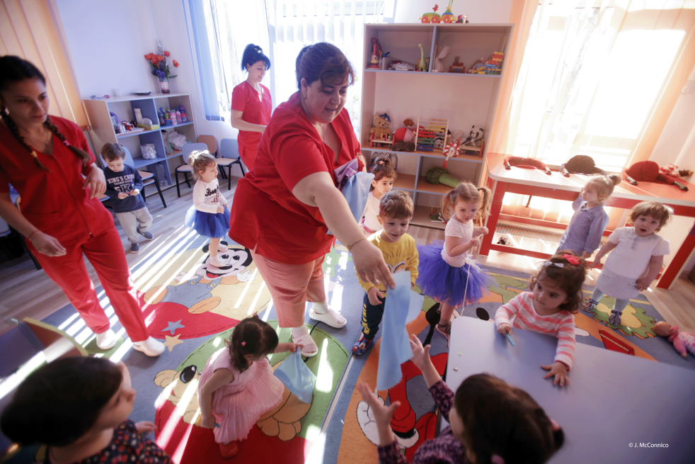
Qualified and Supported ECD Workforce
The success of early childhood systems depends on a qualified and supported workforce. Professionals and practitioners across sectors—health, nutrition, education, and social protection—need access to pre-service and in-service training, continuous professional development, and fair working conditions. A well-prepared workforce that is competent, motivated, and recognized ensures that services are child-centred, inclusive, and effective. When practitioners are valued and supported, the quality and impact of ECD services grow substantially.

Key Actors in ECD Systems at country level
A well-functioning Early Childhood Development (ECD) system depends on the collaboration of multiple actors who share responsibility for shaping, implementing, and sustaining quality services. From national policymakers and local institutions to donors and frontline professionals, each plays a distinct yet interconnected role in ensuring that every young child can develop to their full potential.

National Policy-Makers
Policymakers play a foundational role in ensuring that national priorities reflect the needs of young children. They define rights-based legal and policy frameworks that guarantee access to essential early childhood services (health, nutrition, education, protection). They allocate public resources and set governance mechanisms that foster coordination across ministries and sectors. Their leadership determines whether national systems actively reduce inequities and promote quality, and universal access for all children. Without strong political will and legal foundations, children’s services may remain fragmented, underfunded, or inequitable.

Local/National Actors
Representatives of local and national institutions (e.g., national and local government officials, managers/leaders, training providers, program managers, supervisors, NGO experts) are responsible for contributing to the development and translation of national and local policies into practice. They manage and oversee the planning, implementation, and monitoring of services and programs at national and local levels. They enable intersectoral coordination, ensuring that services are harmonized and responsive to community needs. They also ensure accountability mechanisms and standards are applied consistently across the country. Effective institutions develop timely and relevant national and local policies and operationalize them, ensure service quality, and bridge the gap between high-level commitments and everyday service delivery.

Private Donors
Donors contribute by providing financial resources to support programs, fill funding gaps, and enable innovation in early childhood services. They support capacity-building for governments and institutions to strengthen systems and improve service quality. They also encourage evidence-based approaches and support research and evaluation to improve program effectiveness and reach. Donors play a catalytic role in filling gaps, scaling good practices, promoting equity by targeting underserved populations, and sustaining momentum for quality improvements.

Professionals/Practitioners
Professionals and practitioners — including educators, teachers, special needs professionals, health workers, social workers, mediators, service leaders, etc. — are the frontline of the Early Childhood System. They deliver the day-to-day services that directly influence children’s health, learning, development, and well-being. They build trusting relationships with families and communities, promoting demand for services and fostering nurturing environments. They act as a feedback loop for systems, helping identify gaps, needs, and opportunities for improvement. The quality of services and the experiences that shape young children’s development depend heavily on the skills, commitment, and care of the practitioners who serve them.

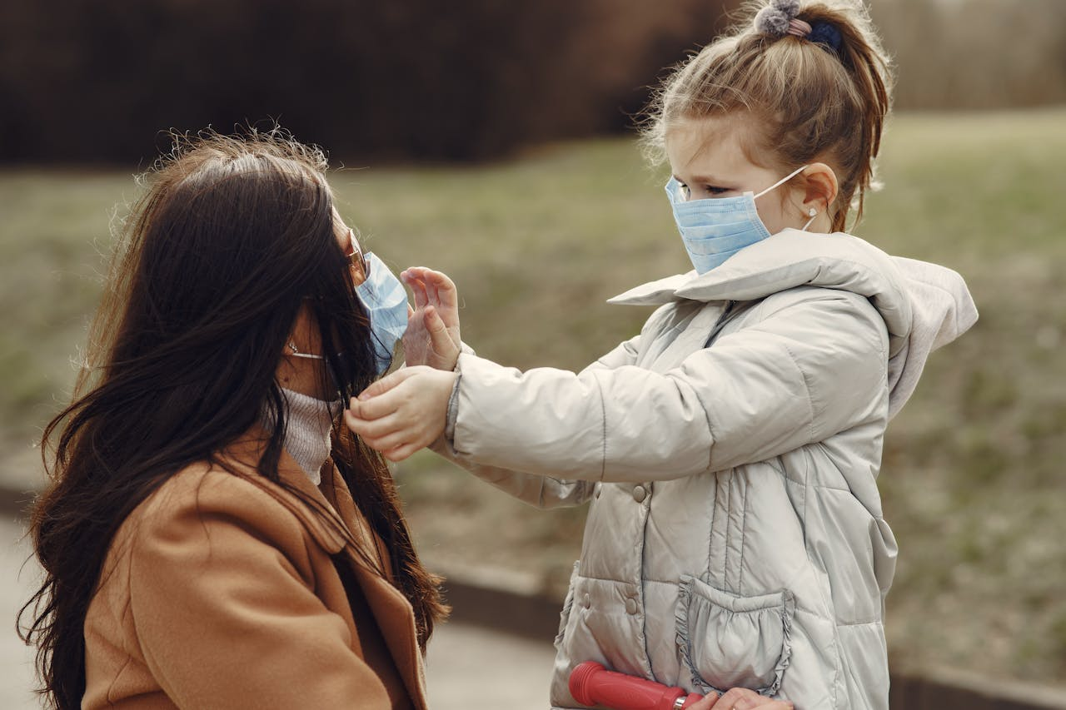

Common Risk Factors for Young Children and Families in Emergencies
When emergencies happen, the weaknesses of early childhood systems become even more evident — highlighting the need to strengthen preparedness to secure young children’s safety and ensure optimal conditions for them to develop and thrive.
Emergencies present great risks for youngchildren’s safety and healthy development, and in many cases, even to their survival. Often, these risks to children are not considered a priority, though the threats young children face can have lasting effects on their well-being and future. To put it more bluntly, there is no emergency situation that does not present risks for them.
The following section outlines the main categories of risks that young children and their families commonly face during emergencies, and the factors that contribute to each.

Disruption of Caregiving and Attachment Relationships
Emergencies can destabilize the close relationships children rely on for safety and emotional security.
- Separation from parents or primary caregivers (due to death, displacement, illness, chaos)
- Caregivers overwhelmed, stressed, or unable to provide consistent care and emotional support
- Decrease in physical and mental health and well-being

Food Insecurity and Malnutrition
Disruptions to food systems and livelihoods threaten children’s nutrition and healthy growth.
- Disruption of food systems leading to inadequate diet
- Economic hardship limiting families’ ability to access or afford nutritious food
- Malnutrition risks can affect brain development, immune health, and overall survival in early childhood

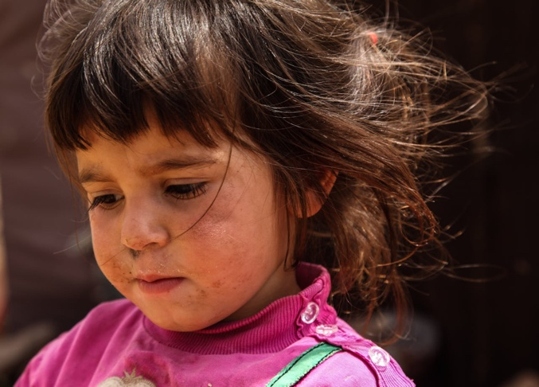
Heightened Risk of Violence, Neglect, Exploitation
Crisis conditions increase children’s exposure to harm, neglect, and exploitation.
- Increased domestic violence, especially in confined or high-stress settings
- Greater risk of child neglect as caregivers face hardship or breakdown
- Exposure to exploitation (e.g., trafficking, forced labor, abuse) in insecure or unmonitored settings

Interrupted Access to Essential Services
Breakdowns in essential services leave children without vital health, nutrition, and learning support.
- Breakdown in routine healthcare (vaccinations, growth monitoring)
- Interrupted access to food, clean water, and sanitation
- Closure or disruption of early childhood services, learning spaces, and childcare

Psychosocial Distress and Toxic Stress Exposure
Exposure to fear, chaos, and uncertainty places children under toxic stress that hinders development.
- Exposure to fear, uncertainty, chaos, violence, or destruction
- Lack of safe spaces for play, learning, and emotional recovery
- Chronic toxic stress undermining early brain development

Unsafe Living Conditions
Unstable or overcrowded environments during crises compromise children’s safety and well-being.
- Loss of home and stable environment
- Overcrowded, temporary shelters not adapted to young children’s needs
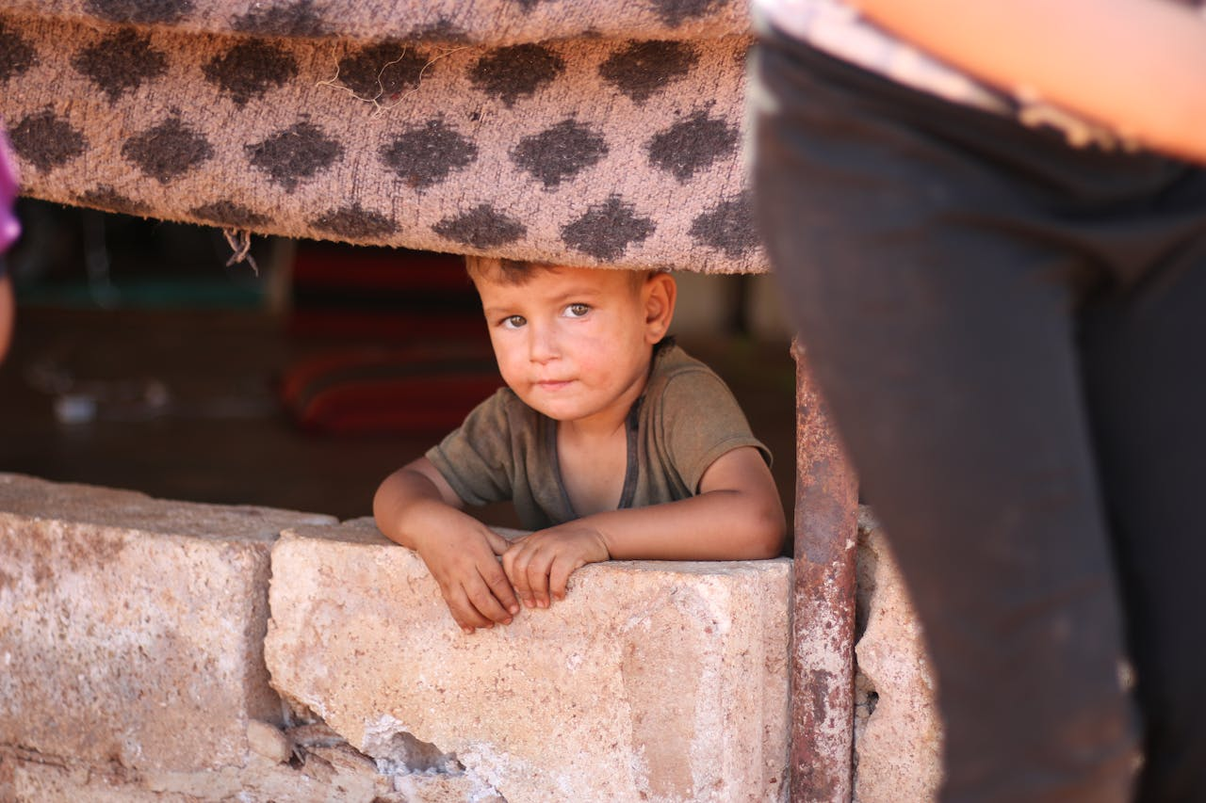
- Increased exposure to physical dangers and environmental hazards

Core Components of Early Childhood System Preparedness for Emergencies
Crises, whether natural disasters, conflicts, pandemics, or economic shocks, can strike without warning, disrupting the lives of millions of young children and their families. These disruptions often deepen existing inequalities, sever access to essential services, and jeopardise the developmental foundations laid in the earliest years of life. To protect children’s well-being and rights, early childhood systems must be prepared, able not only to withstand shocks but also to adapt, recover, and continue supporting holistic development.

Preparedness is more than having contingency plans: it is about building resilient systems that are agile, inclusive, and sustainable. Preparedness is also not a technical exercise, but a collective commitment to uphold the rights and potential of every young child, in every circumstance. It requires foresight, investment, unwavering dedication and coordination across all levels, from policy and governance to community and service delivery.

The sections that follow outline five core components of system preparedness and show how they can be applied across different emergency contexts—displacement, natural disasters, pandemics, and conflict—to protect young children and their families.
ISSA’s compendium identifies five core components of preparedness that together enable systems to respond effectively and equitably in times of crisis.

Emergency response
Emergency Responses is the system’s ability to mobilise quickly and effectively when crisis strikes. Preparedness for emergency response means having clear protocols, adequate resources, and well-coordinated partnerships in place to secure continuity of essential early childhood services and support. The goal is to prevent service collapse and protect children’s safety and development during the most critical moments.

Flexible service delivery
Rigid systems fail under pressure. Flexible service delivery allows for adapting models, locations, and modalities to meet changing needs—whether through home visits, digital platforms, or community-based hubs. This flexibility ensures that every child, especially those in vulnerable contexts, can access support, regardless of circumstances.

Workforce capacity and well-being
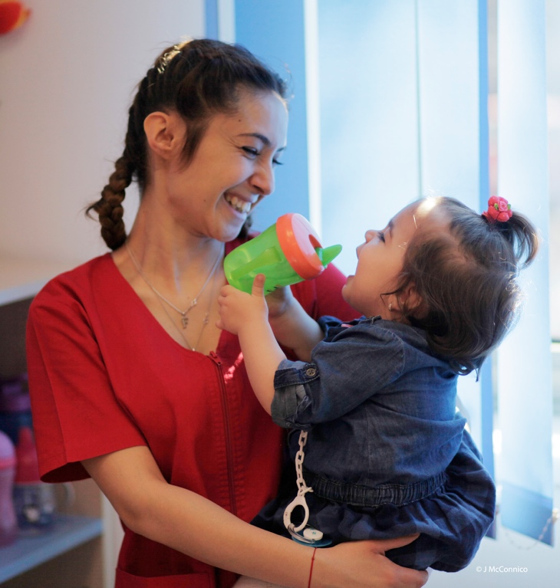
The early childhood workforce is the backbone of service delivery. In times of crisis, their skills, resilience, and well-being determine whether services can continue and maintain quality. Investing in capacity-building, continuous professional development, and psychosocial support strengthens this critical workforce, reducing burnout and safeguarding their ability to care for children and families.

Integrated mental health and psychosocial support (MHPSS)
Emergencies place immense stress on children, families, and professionals. Integrating MHPSS into early childhood programs during the immediate emergency response and in early childhood services post-immediate emergency, ensures holistic care that addresses emotional and psychological needs, not just survival. When mental health is prioritised alongside physical safety and education, systems foster resilience, stability, and healthy development.

Governance, coordination, and accountability
Preparedness demands strong leadership, clear roles, and mechanisms for collaboration and transparency across sectors and levels of governance. Without alignment, crisis response risks being fragmented and inequitable. Effective governance ensures that resources are used wisely, decisions are evidence-based, and systems remain accountable to the children and communities they serve.

These components do not operate in isolation. Their true power lies in integration: when emergency response is guided by robust governance, when flexible services are enabled by a skilled and supported workforce, and when mental health of children, families and professionals is treated as essential to child development. Together, they create systems that can withstand shocks, maintain equity, and emerge stronger from adversity.
Explore how those components can translate into practice in the case of emergencies to best support young children and their families.

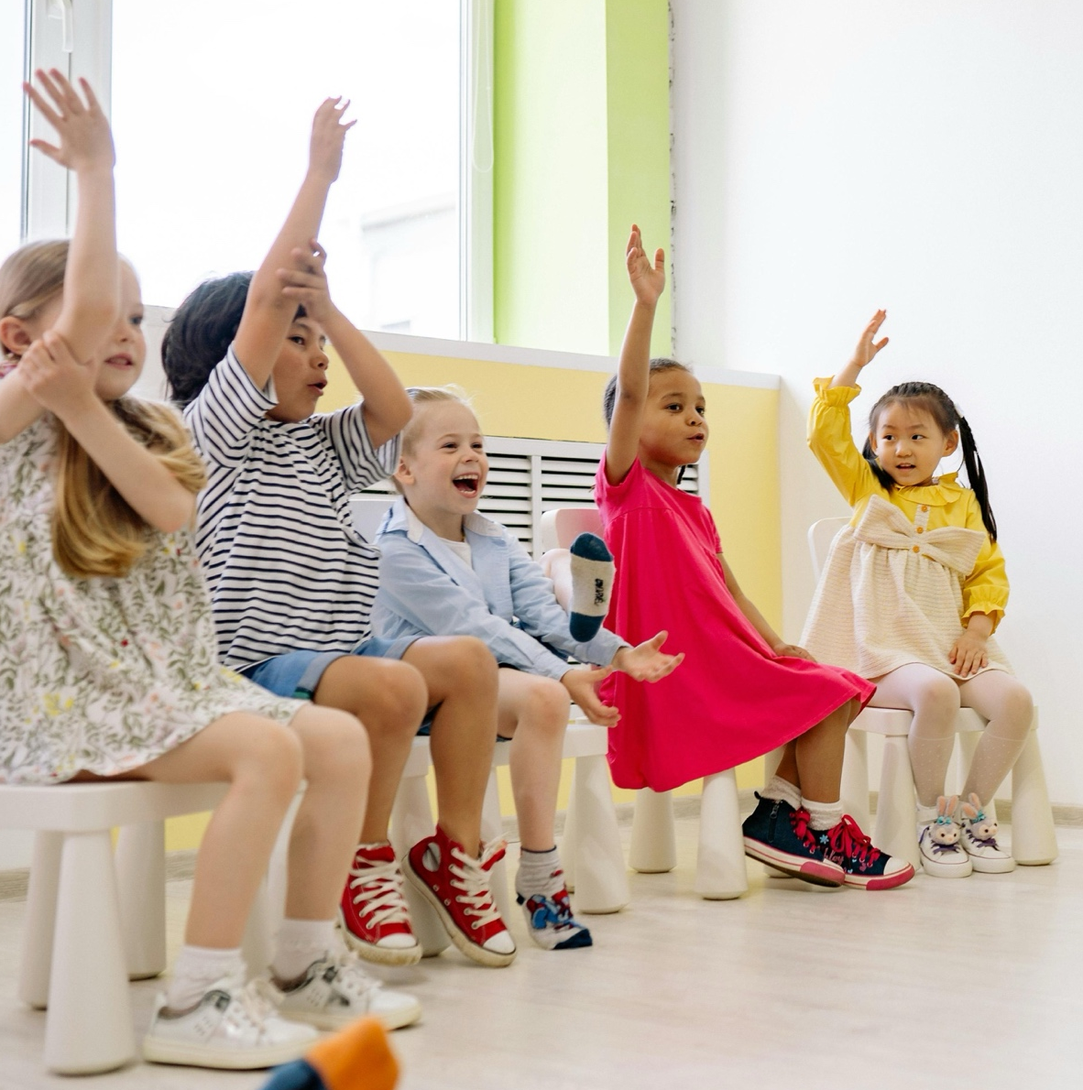


ISSA’s Journey in Preparedness and Response to Emergencies

ISSA’s Journey in Preparedness and Response to Emergencies
Across diverse contexts and crises, ISSA members have demonstrated how early childhood systems can adapt, respond, and recover to protect young children and families. The stories that follow illustrate how the five core components of preparedness take shape in practice:
- Emergency Response
- Flexible Service Delivery
- Workforce Capacity and Well-being
- Integrated Mental Health and Psychosocial Support
- Governance, Coordination, and Accountability
Each component is accompanied by a table showcasing examples from ISSA members. These illustrate concrete actions taken in different emergencies — offering insight into how preparedness principles are applied in real settings, and how systems evolve to meet the complex realities children and families face.

Emergency response
This section highlights how early childhood systems can act fast when emergencies strike. It features ISSA members’ approaches to protecting young children and families across different crises.
Action Area | ISSA Member Story | ISSA Member Organisation | Emergency Type
Rapid Response Teams:  Locally and nationally positioned teams that can be swiftly deployed to meet the urgent needs of young children and their families during crises. | Emergency support to Roma families from Transcarpathia, Ukraine, fleeing to Hungary | Partners Hungary Foundation, Hungary | Displacement
Resource Allocation: Mechanisms to ensure immediate access to essential supplies, services, and logistical support to maintain and restart ECD interventions. | Supporting vulnerable young children and families during COVID-19 | Trust for Social Achievement & Worldwide Foundation for Vulnerable Children, Bulgaria | Pandemic
Contingency Planning:  Risk analysis, early warning systems, and pre-crisis planning that prioritize young children in emergency response frameworks. | Advocacy efforts for an inclusive early childhood system | Step by Step Center for Education and Professional Development, Romania | Displacement

Emergency support to Roma families from Transcarpathia fleeing to Hungary
Rapid Response Teams | Displacement | Partners Hungary Foundation, Hungary
What happened?
In February 2022, when Russia invaded Ukraine, many Hungarian-speaking Roma families fled to Hungary. Children arriving in border areas and Budapest faced instability, trauma, and limited access to safe environments, play spaces, and education.
What was needed? How did Partners Hungary Foundation respond? Urgent needs included:
- Safe play spaces for children
- Support for social integration
- Trauma-informed care
- Legal guidance for families

Partners Hungary Foundation mobilized quickly at train stations and temporary shelters, supporting refugee families—especially Roma. They provided play-based activities for children and legal guidance for families on registering for social security numbers, healthcare, and residency. A Mini PlayHub was established near Lake Balaton (Fonyód), offering non-formal education, psychosocial support, and a welcoming environment for displaced children and their caregivers.
Key Challenges
- School access barriers: Local schools were full or hesitant to enrol refugee children.
- Discrimination: Roma families were deprioritized for aid and housing.
- Language and trauma: Refugee children and parents faced psychological distress and communication hurdles.
Solutions:
- Mini PlayHubs provided safe, nurturing environments for play and learning.
- Volunteer teachers and psychologists offered trauma-sensitive activities.
- Parents received legal support and referrals to essential services.

This response was built on strong collaboration between Partners Hungary, Nesting Play, local municipalities, War Child, UNHCR partners, ICDI and the ISSA Network Hub. Collaboration enabled resource sharing and replication of good practices. Children had access to environments where they could recover, play, and reconnect. Trust between Roma and Ukrainian families grew through shared participation and learning.
What's in place? What's missing?
While strong NGO capacity enabled a rapid and compassionate response, the absence of a formal, system-level preparedness framework limited the scale and consistency of support. Without coordinated government leadership, the response remained fragmented and dependent on local initiative. This example illustrates both the strength of a responsive civil society and the critical need to institutionalise ECD-specific preparedness within national systems to ensure young children are not left behind in future emergencies.

Being part of a regional network: Advantages of ISSA membership
ISSA provided vital support through: training-of-trainers programs, enabling cross-country knowledge exchange and peer learning with other members in Ukraine and countries receiving Ukrainian refugees. Being part of ISSA meant rapid access to tools, capacity-building, and a community of practice — all of which helped Partners Hungary respond swiftly and effectively.
Recommendations
National policymakers:
- Enact emergency legal frameworks for rapid issuance of social security numbers, school placement, and healthcare registration at borders.
- Mandate inclusive non-discrimination policies that guarantee equal access for all refugees, with monitoring and enforcement.
- Allocate funding for mobile ECD units in crisis zones and integrate them into national emergency preparedness plans.

Local/national actors
- Train and deploy intercultural mediation teams to liaise with families, schools, and service providers.
- Embed Play Hubs or mobile learning spaces as standard crisis interventions—already pre-planned and budgeted.
- Foster collaboration across sectors—education, health, social services—to coordinate rapid ECD responses.

Private donors
- Prioritize multi-year, flexible grants that empower local operation teams and scale mobile ECD solutions.
- Support capacity building—train staff in trauma-informed care, stress and crisis response.
- Fund pilot projects from which best practices (like PlayHubs) can be developed and shared across regions.

Professionals/practitioners
- Seek or advocate for training in trauma-informed play and psychosocial support.
- Build mobile, pop-up ECD kits and toolkits—activity cards, portable toy packs, language support materials.
- Establish networks among ECD providers to share evidence-based protocols and coordinate rapid deployment.
Explore further: Partners Hungary: supporting Ukrainian refugee children and families

Supporting vulnerable young children and families during COVID-19
Resource Allocation | Pandemic | Trust for Social Achievement and Worldwide Foundation for Vulnerable Children, Bulgaria

What happened?
In early 2020, the COVID-19 pandemic imposed strict lockdowns across Bulgaria. As families, including many from marginalised groups like Roma, found themselves isolated at home, access to early childhood education, play, and developmental support abruptly stopped. Local services closed, and traditional means of engaging children and parents in learning and care were disrupted.
What was needed? How did they respond?
Urgent needs included:
- Continuity of early childhood development and parent support, despite service disruption
- Accessible, home-based resources for learning and skill-building
- Strengthened local capacity and flexibility among service providers
TSA and the Worldwide Foundation for Vulnerable Children joined forces to address these urgent needs. Operating through local grassroots partners, they quickly shifted to home-based support strategies:
- TSA mobilised its network of community organisations to sustain early childhood services and advocate for affordable access to care and education.
- The Worldwide Foundation for Vulnerable Children deployed its “Element of Play” program—a trauma-informed, play-based approach using play, music, and storytelling—to reach vulnerable children at home, through remote means or small-scale local delivery. To meet the needs of vulnerable families with children staying at home during the pandemic, WFVC developed a version of the program “Stay at home, play at home” that provides parents with ideas for games using materials they have at home.
- Together, the organisations emphasised the importance of adaptability, collaboration, and a human-centred approach, reinforcing the core values of empathy, solidarity, and resilience during crisis.
Key Challenges
- Lockdowns forced the closure of in-person early education, leaving gaps for children's stimulation and learning.
- Families from disadvantaged backgrounds—particularly Roma—faced greater barriers in accessing digital resources or quality home-based support.
- Local grassroots providers needed rapid upskilling in remote delivery and trauma-informed care, while maintaining trust within the community.

Solutions:
- TSA, with its established community connections, and the Worldwide Foundation leveraged their networks to deliver responsive, localised early childhood care via remote consultations, resource sharing, and community outreach.
- The “Element of Play” method continued to support children’s development, even under lockdown, through engaging, restorative play, storytelling, and music, adapted for home or caregiver facilitation.
- Community-based organizations and health and educational mediators are a vital link between disadvantaged communities and the important services children and families need, particularly in times of crisis.

TSA, along with other civil society actors, pursued policy-level advocacy to ensure more inclusive access to early childhood services, while also equipping local organisations with tools, data, and training to sustain their work under uncertainty.
The experience of TSA and the Worldwide Foundation during the pandemic underscores a vital lesson: flexibility saves services. Local organizations that were able to pivot swiftly to home-based and digital solutions ensured that vulnerable families continued to receive care and developmental support. At the heart of these efforts was play. Far more than a pastime, play proved to be a lifeline for children, offering both learning opportunities and emotional resilience during a time of uncertainty and stress. These initiatives also highlighted the power of collaboration: by bringing together TSA’s advocacy expertise and the Worldwide Foundation’s specialised, trauma-informed play methodologies, the response addressed not just immediate needs but also systemic gaps in early childhood provision.
What’s in place? What’s missing?
Today, Bulgaria has more experience in preparing for future crises than before the pandemic. Community-based organizations have been equipped with tools for remote and hybrid service delivery, while the “Element of Play” program stands as a proven model for maintaining continuity in early childhood development, even under restrictive conditions. TSA’s advocacy efforts have also strengthened the conversation around equitable access to early childhood services, ensuring that affordability and inclusion remain priorities on the policy agenda.
Yet, significant gaps remain. Sustained funding is critical to avoid losing the progress made and to keep crisis-adapted services operational in the long term. Digital inequity continues to pose a serious challenge, as many marginalised families lack the devices and connectivity required for remote learning. Moreover, while trauma-informed, play-based approaches have demonstrated their value, they are not yet fully integrated into national early childhood systems—leaving room for policy innovation and structural reform.
Being part of a regional network: Advantages of ISSA membership
Being part of the regional network of ISSA felt truly empowering during COVID. It offered a supportive space to share not only successful approaches that can help others, but also the worries and challenges we all faced along the way – as experts, and as individuals. Knowing there’s a community of like-minded professionals to turn to during difficult moments provided comfort and strength. We felt more hopeful and more united in our mission to make a real difference in children’s lives across the region.

Recommendations
National Policymakers
- Institutionalize crisis preparedness plans that prioritize continuity of services for vulnerable children and families.
- Foster multi-sectoral collaboration among government, civil society, and private sector to ensure inclusive access and systemic reforms.
- Develop policies that promote flexible, remote, and hybrid service delivery models for early childhood education.
- Integrate trauma-informed, play-based approaches into the national early childhood development policies.
- Secure sustained funding to support digital infrastructure, especially targeting marginalized communities to bridge digital inequity.

Local/National Actors
- Strengthen local capacities through continuous training in remote service delivery, trauma-informed care, and community engagement.
- Utilize local networks and community-based organizations to facilitate outreach, trust-building, and service delivery during crises.
- Strengthen capacity, training and provide sustainability to the role of health, educational mediators as a vital link between communities and services.
Private Donors
- Support capacity-building initiatives for local organizations to enhance remote and trauma-informed service delivery.
- Fund advocacy and policy reform efforts aimed at integrating innovative, flexible and trauma-informed approaches into national systems.
Professionals/Practitioners
- Adopt flexible, culturally sensitive play-based methodologies to support children’s emotional and developmental needs during crises.
- Increase skills in remote delivery techniques, digital tools, and culturally sensitive engagement with families.
- Collaborate closely with community mediators and local organizations to build trust and ensure effectiveness of outreach.
- Stay adaptable, continuously updating practices based on emerging evidence and community feedback.
- Advocate within their organizations/professional networks for policies and resources that support inclusive, flexible, and trauma-sensitive early childhood services.
Explore further: Member in Focus: TSA and Worldwide Foundation for Vulnerable Children | ISSA

Advocacy efforts for an inclusive early childhood system
Contingency Planning | Displacement | Step by Step Centre for Education and Professional Development, Romania
What happened?
In 2022, Romania faced a dual challenge: responding to the urgent needs of Ukrainian refugee children while also addressing pre-existing inequalities affecting vulnerable Romanian children. As the war in Ukraine continued, deepening these inequities, the Step by Step Centre for Education and Professional Development (CEPD) intensified its advocacy efforts through the First Years, First Priority campaign. The aim was clear: keep early childhood development (ECD) at the forefront of public attention and policymaking, ensuring that both refugee and local children’s rights to education, care, and protection were equally recognised.
What was needed? How did CEPD respond?
With the arrival of refugee families and the ongoing social and economic challenges for many Romanians, there was a risk that ECD would be deprioritised. CEPD responded by advocating for an inclusive approach to policy and services, reminding decision-makers that helping one group of children should never mean neglecting another. The campaign emphasised equity, continuity of services, and the integration of all children into early childhood systems.
Key Challenges
- Overlapping crises, war-driven migration and entrenched inequities stretched public resources and attention.
- Competition for funding and services risked creating divisions between refugee and local communities.

Solutions:
- Continued public and political advocacy through the First Years, First Priority campaign.
- Clear messaging that early childhood investment benefits all children and strengthens society as a whole.

The campaign brought together NGOs, experts, and civil society groups to speak with a unified voice. This coalition ensured that the needs of all young children, regardless of background, remained a national priority, even during crisis response planning. By sharing this advocacy example within the ISSA Network, CEPD’s approach serves as a model for other members navigating similar crises, demonstrating that strong, consistent advocacy can influence national agendas even when emergency response systems are under strain.
What’s in place? What’s missing?
CEPD entered the crisis with a strong advocacy track record and an active stakeholder network, enabling it to act quickly when the war in Ukraine began impacting Romania. However, because there was no formal, government-led contingency framework to secure ECD priorities during emergencies, visibility and funding for young children’s needs remained vulnerable, relying entirely on civil society’s capacity to respond and maintain pressure.
Being part of a regional network: Advantages of ISSA membership
Membership in ISSA has given CEPD and its partners access to peer learning, tested advocacy strategies, and international visibility. The network strengthens collective voices, promotes solidarity across borders, and ensures that inclusive early childhood development remains a shared regional priority even in times of crisis.

‘’At the PrimoHUB, my daughter felt safe and welcomed. She began learning Romanian through play, and I received guidance on how to support her. It was the bridge we needed between our home and the kindergarten.’’
Parent (Ukrainian mother)

Recommendations
National Policymakers
National decision-makers should establish a clear contingency framework for early childhood in crises, secure stable and equitable funding for all children (refugee and local), expand Romanian as a second language courses including for preschoolers, and introduce data monitoring that disaggregates outcomes by status to guide future policy.

Local/National Actors
Local institutions and NGOs can strengthen inclusion by developing community-based hubs like Primo HUB, fostering partnerships to pool resources rather than compete, and training practitioners in inclusive, trauma-sensitive methods. They can also create shared platforms for extracurricular and after-school resources to ensure continuity for children.
Private Donors
Philanthropic actors and CSR programs should provide flexible, rapid-response funding, invest in professional capacity-building, and support innovative pilots such as digital tools or parenting programs that can later be scaled. Donor strategies should reinforce solidarity and equity, showing that early investment benefits all children.
Professionals/Practitioners
Teachers, caregivers, and social workers can adapt classroom practice to children’s diverse needs, use inclusive methods, and engage parents as active partners. By joining professional development and peer-learning initiatives, they gain new tools and confidence, while their testimonies serve as powerful advocacy for inclusive education.
Explore further: Advocacy efforts in Romania continue while war deepens inequities

Flexible service delivery
This section showcases how ISSA members adapted services to reach young children and families when access to early learning, care, and health was disrupted. From mobile units to community-based learning, these approaches ensured continuity despite instability.
Action Area | ISSA Member Story | ISSA Member Organisation | Emergency Type
Safe Learning Environments: Development and maintenance of crisis-ready ECD spaces that offer safety, continuity, and protection for young children. | SPYNKA Program | Comenius Foundation for Child Development, Poland | Displacement
 | Creating safe learning environments to counter war disruption | Ukrainian Step by Step Foundation, Ukraine | War and Conflict
Flexible Delivery Models: Use of mobile, community-based, and intergenerational approaches to sustain access to early learning and care. | TOY for Inclusion | International Child Development Initiatives (ICDI), Netherlands | Displacement
 | Mobile units bring ECD services to underserved areas | Mother Child Education Foundation (AÇEV), Türkiye | Natural Disaster
Inclusive Access: Creating safe, accessible community spaces for displaced and host-community children. | Station of Hope shelter and learning centre | Transcarpathian Regional Charitable Fund Blaho, Ukraine | War and Conflict

SPYNKA Program
Safe Learning Environments | Displacement | Comenius Foundation for Child Development, Poland
What happened?
Following the outbreak of war in Ukraine in early 2022, over 1.6 million refugees arrived in Poland—most were women and children. The national system struggled to meet the needs for childcare and early education, prompting urgent intervention.
What was needed? How did Comenius Foundation for Child Development respond?
Parents, especially mothers needing to work, needed safe, full-day early childhood care for their young children. The Comenius Foundation for Child Development created the SPYNKA program, launching drop-in childcare centres adjacent to reception points for children aged 2-6 years old. The program expanded to include Ukrainian-Polish:
- Full-day nurture-based nursery programs for children 1-3 years old
- Full-day nurture-based toddler programs for children 4-6 years old
Key Challenges
- Limited formal childcare infrastructure to serve refugee children.
- Mothers needed reliable childcare support to work or stabilise their families.
- ECEC workforce was limited and inconsistent.

SPYNKA was implemented in partnership with UNICEF, local municipalities, NGOs, and international agencies. Though many municipalities lacked space, Comenius Foundation rented their own centres to ensure service continuity.
Solutions:
- Expanded the program rapidly with UNICEF support to 75 centres across eight provinces, reaching ~10,000 children and mothers.
- Provided high-quality, holistic, child-oriented non-formal ECEC, preparing children for school and supporting socio-emotional development.
- Equipped centres with games, books, art supplies, and hot meals.
- Offered job opportunities to parents, especially mothers, in the centres.
- Provided specific training to ECEC practitioners on Psychological First Aid and trauma-informed practices.

This close coordination enabled consistent, full-day care, helping refugee children find stability and integration, while parents gained time and support to rebuild their lives.
What's in place? What's missing?
SPYNKA is a compelling example of how rapid, locally driven contingency planning can meet urgent early childhood needs in crisis. Comenius Foundation’s agile approach and community response were vital—but the absence of formal, state-level contingency systems means such programming remains contingent on civil society. To ensure consistent, equitable access for all refugee children in future crises, early childhood care must be integrated into national preparedness frameworks.
Being part of a regional network: Advantages of ISSA membership:
Membership in ISSA provides the Comenius Foundation team and smaller non-governmental organisations cooperating with us with access to knowledge and a network of organisations that share their experiences. We have the opportunity to participate in international activities to strengthen advocacy efforts regarding the importance of early childhood. In the event of a crisis, we can be sure that we will not be left alone and that we can count on substantive and organisational support.
Recommendations
National Policymakers
- Creating emergency preparedness plans that emphasise the importance of care and safety for children in the refugee crisis.
- Establishing cooperation between the government, local authorities, non-governmental organisations and local groups to ensure constant communication and prevent duplication of efforts
- Ensuring continuous funding and efficient flow of information on opportunities to support the safety and care of children and their families.
- Ensuring funding for education and care infrastructure by creating mobile centres for the care and education of young children (Spynka mobilna).

Local/national actors
It is necessary to strengthen the integration and networking of local non-governmental organisations whose mission is to help children in difficult situations. Local and regional non-governmental organisations should join together in supportive rather than competitive groups. All horizontal initiatives and the sharing of knowledge and potential are of great importance not only for the quality of work with children, but also for the effectiveness and efficiency of help.
Private donors
Securing funding for programmes for refugee children from private donors, corporate social responsibility departments and corporate foundations, together with funding for capacity-building programmes for organisations that provide such assistance.
Professionals/practitioners
- Developing knowledge in the field of pre-specialist assistance, psychological first aid, building resilience and working with trauma. It is very important to be able to work with parents who, for many reasons (trauma, cultural differences, difficult living conditions), are unable to provide support for their children.
- Developing knowledge about the possibilities of specialist assistance and reference points for further assistance.
- Building one's own mental resilience and the ability to give and receive support within a team of professionals.
Main takeaways: The SPYNKA model underlines how safe, structured, nurturing spaces staffed by trained personnel can anchor young children and caregivers amidst displacement. These environments not only ensure continuity of learning but also serve as critical emotional and protective settings during crises—especially when designed with trauma-awareness, cultural sensitivity, and daily routines at their core.
Explore further : Spynka.org - Program SPYNKA wspiera dzieci i matki z Ukrainy

Creating safe learning environments to counter war disruption
Safe Learning Environments | War and Conflict | Ukrainian Step by Step Foundation, Ukraine
What Happened?
By May 2022, Trostianets, a city in Ukraine’s Sumy region, had none of its kindergartens open following war-induced destruction. With support from War Child Holland, Ukrainian Step by Step Foundation (USSF) worked closely with the local municipality to reactivate local early childhood settings by providing essential materials (furniture, toys, meals, stationery), enabling kindergartens to reopen in safe conditions by June and September. Alongside physical reconstruction, ECEC staff received Psychological First Aid (PFA) training to support emotional recovery for children and families.
What was needed? How did USSF respond?
Children returning to the community needed safe, supportive environments that addressed both physical risks and emotional trauma. Trostianets educators were rapidly trained to create safe learning spaces, even in bomb shelters, and to facilitate healing-centred play and interaction, helping children process their experiences.
Solutions:
- Rehabilitated kindergartens and shelters to become fully operative and equipped as safe learning environments for young children.
- Equipped ECEC staff with psychological first aid, self-regulation techniques, play-based guidance, and strategies for comforting children in unstable conditions.

Key Challenges
- Ongoing infrastructure damage and electricity crises made it difficult to recreate safe and consistent learning environments.
- Children’s stress manifested through war-themed play, and parents lacked skills to support emotional recovery.

The joint effort of the Ukrainian Step by Step Foundation, the ISSA Network Hub and War Child Holland ensured a coordinated response: heart restored to damaged education infrastructure and emotional resilience built into the reopening of kindergartens. The cross-sector collaboration made timely, context-sensitive action possible.
What's in place? What’s missing?
Trostianets benefited from quick action to reopen kindergartens and from ECEC staff equipped with Psychological First Aid skills who could adapt learning spaces even under blackout conditions. Yet, without a formal, emergency-ready ECD infrastructure or crisis-specific delivery guidelines, the resumption of safe learning relied heavily on individual efforts rather than on a coordinated, systemic framework.
Being part of a regional network: Advantages of ISSA membership:
- Feeling of support as a part of ISSA community – both at the organizational and personal levels
- Opportunity to get informational, training and financial support (some mini grants)
- Exchange of experience between the countries
Recommendations
Stakeholders at all levels should focus at the following priorities:
- Safety and protection of children: shelters in the preschools, developed plans of evacuation.
- Flexible formats of functioning: face-to-face activities and online, video for parents, using other spaces (library, etc) for short-term activities.
- Psychosocial support: availability of psychologists, using art (play, fairy-tales)-therapy, training for teachers and parents.
- Support of parents and local communities: parents` clubs, parents` involvement.
- Inclusiveness and accessibility: adopted materials, support of additional specialists.
- Coordination and management: collection of relevant data, coordination with the national/local authorities, private business, donors.
National policymakers: providing legal documents.
Local/national actors: funding, coordination with other stakeholders
Private donors: providing financial and other support (materials, training)
Professionals/practitioners: training on the providing psychosocial support to children and parents, to develop their own resilience.
Explore further: https://issa.nl/index.php/content/psychological-first-aid-training-guards-childrens-safety-trostianets-ukraine

TOY4Inclusion
Flexible Delivery Models | Displacement | International Child Development Initiatives ICDI, The Netherlands
What happened?
In July 2022, the International Child Development Initiatives (ICDI), in partnership with Škola dokorán in Slovakia and Partners Hungary Foundation in Hungary, launched TOY for Inclusion Play Hubs to support young Ukrainian refugee children and their caregivers. These hubs offer inclusive, community-based, non-formal ECEC spaces where play, connection, and learning can occur in safe, welcoming environments.
What was needed? How did ICDI respond?
Refugee children faced challenges enrolling in formal education: in Slovakia and Hungary, about 40% of preschool-aged Ukrainian children weren’t registered due to language barriers, school capacity limits, or intentions to stay temporarily. In response, ICDI coordinated with partners to open fixed and mobile Play Hubs in Slovakia and Hungary, offering socialisation, emotional support, language learning, and safe access points to wider services.
Key Challenges
- High proportion of refugee children not enrolled in schools due to limited space, ongoing displacement, or language obstacles.
- Maintaining program quality and consistency outside of formal centres.

Solutions:
- Established local, community-based Play Hubs, both fixed and mobile, to provide inclusive, welcoming spaces.
- Offered multi-service support: emotional care, group play, referrals to further services, language learning, and integration opportunities.

ICDI partnered with TOY national coordinators, Škola dokorán in Slovakia and Partners Hungary in Hungary, municipalities and institutional donors like UNICEF and EPIM. This coordination led to the strategic placement of PlayHubs, maximising accessibility across regions. The approach helped children build connections, ease linguistic and emotional barriers, and find pathways to formal services.
ICDI and partners were later able to share resources through the ISSA network and beyond like the “Play for Inclusion Handbook” and “Mobile Play Hub Operating Guidelines” (in multiple languages, including English, Slovak, Hungarian, and Ukrainian) to scale the model across contexts.
What's in place? What's missing?
The TOY for Inclusion Play Hubs showcase a compelling example of adaptive, flexible ECD service delivery in times of crisis, bridging gaps left by formal education systems. However, their effectiveness depended entirely on NGO-led innovation and ad hoc partnerships. To ensure equitable support for all young refugee children in similar emergencies, flexible ECD delivery models must be embedded into formal national preparedness systems.
Being part of a regional network: Advantages of ISSA membership:
Being part of a network such as ISSA has been instrumental in developing and scaling initiatives like TOY4Inclusion, which was co-created by ISSA members in 2017. The network provides a trusted platform for knowledge exchange, peer learning, and innovation, enabling members to pilot inclusive approaches, share evidence, and adapt solutions across countries. Through ISSA’s collective advocacy and partnerships, organisations can amplify their impact, influence policy, and secure resources to bring community-based models—such as Play Hubs—to scale. Implementing projects in partnership or within a network also strengthens quality assurance and joint monitoring and evaluation (M&E) by offering shared tools, peer reviews, and evidence frameworks that ensure services like Play Hubs are effective and accountable.
This regional collaboration fosters solidarity and responsiveness, and continuous improvement in ECEC systems and services. Ensuring they can better address challenges like migration, displacement, and inequality.

Recommendations
National Policymakers
- Integrate early childhood development (ECD) and play-based learning in emergency and refugee response plans.
- Invest in community-based non-formal ECEC services like Play Hubs to bridge home and formal schooling.
- Mandate intersectoral cooperation across education, health, and social protection.
- Embed UNCRC and MHPSS guidelines into national strategies.
- Fund training and accreditation for ECEC staff and volunteers.
Local/National Actors (NGOs, Municipalities, Community Groups)
- Create inclusive, family-friendly spaces that promote belonging and integration.
- Use Local Action Teams for context-specific, community-driven services.
- Provide psychosocial support for both families and frontline staff.
- Incorporate intergenerational learning to strengthen community ties.
- Monitor and evaluate impact using participatory tools.
Private Donors and Philanthropies
- Prioritise ECD funding in humanitarian and displacement contexts.
- Provide flexible, rapid-response and sustainable funding.
- Support workforce capacity building and innovative approaches like mobile Play Hubs.
- Invest in cross-country learning and peer-exchange platforms.
Professionals and Practitioners
- Apply trauma-informed, nurturing, and predictable care practices.
- Foster children’s participation, creativity, and cultural identity.
- Engage families actively through clubs, sessions, and co-created activities.
- Prioritise practitioner well-being and peer support.
- Use the Handbook’s activity cards and tools for practical guidance.

Explore further: Mobile Play Hubs for Ukrainian refugee children in Hungary and Slovakia
Play Hubs: nonformal ECEC supporting young Ukrainian children in Slovakia and Hungary
Operating Guidelines Mobile Play hubs
Activity Cards Mobile Play Hubs
Research report Mobile Play hubs
Play for Inclusion handbook
Play for Inclusion Activity Cards

Mobile units bring ECD services to undeserved areas
Flexible Delivery Models | Natural Disaster | Mother Child Education foundation AÇEV, Türkiye

What happened?
On February 6, 2023, two major earthquakes struck southeastern Turkey, affecting 11 provinces, causing large-scale displacement, and disrupting essential services for children and families. Many communities, especially in rural areas and small settlements, faced long-term interruptions to early childhood education and support.
What was needed? How did ACEV respond?
Children in remote villages and small container settlements were left without safe learning spaces, structured activities, or developmental support. Caregivers lacked guidance on supporting their children’s well-being in the aftermath.
In addition to setting up Child and Family Centers in major temporary shelters, AÇEV deployed mobile education units to deliver six-week structured early learning for children and POWER Program for women directly to underserved areas in Hatay and Gaziantep. These mobile units brought play-based learning, art activities to children aged 3–6 and women empowerment sessions to women, ensuring that even those far from centralized services could access early childhood development opportunities.
Solutions:
- Use of fully equipped mobile units staffed with trained early childhood educators.
- Tailored program design to fit shorter, intensive six-week cycles.
- Continuous monitoring and supervision to maintain fidelity to AÇEV’s evidence-based methods.

Key Challenges
- Geographic dispersion of families in smaller, rural settlements.
- Limited transportation and infrastructure in disaster-affected regions.
- Maintaining program quality and consistency outside of formal centers.

Collaboration with the Ministry of Family and Social Services and donors such as UNICEF, Vodafone Foundation, Fondation de France, James Dyson Foundation and CitiBank enabled rapid mobilisation of resources, staff recruitment, and local permissions. Local community leaders facilitated access to villages, increasing reach and trust.
Through ISSA’s network, AÇEV could draw on global ECD in emergencies guidance, share mobile outreach practices with peers, and position its model as an adaptable approach for other crisis contexts. The network link also amplified advocacy for integrating mobile delivery into national emergency preparedness plans.
What's in place? What's missing?
AÇEV’s prior expertise in program delivery and trained local staff provided a foundation for adaptation, but the absence of ready-made rural delivery systems created a risk of leaving remote families without services. Mobile units bridged this gap, ensuring inclusion and continuity.
Being part of a regional network: Advantages of ISSA membership:
Being part of a regional network like ISSA helps members learn from each other, share knowledge, and improve their work through training and support. The network also makes it easier to build partnerships and work together across countries. For example, ISSA helped AÇEV share its programs by supporting translation into different languages and encouraging others to use them. These kinds of networks help good ideas grow and reach more people.

Recommendations
National Policymakers
- Developing emergency response plans that prioritize children and families at risk.
- Building partnerships between government, local officials, NGOs, and community organizations in order to achieve a more inclusive and comprehensive solution.
- Providing psychosocial support to the families in order to sustain the well-being of the children.
Local/National Actors (NGOs, Municipalities, Community Groups)
- Flexibility of programs to adapt to diverse needs and cultural contexts.
- Partnerships
- Creating community centers for all children, teenagers, women and families as a safe space to connect and engage.
- Regular monitoring to confirm that all families and children are participating in the programs without challenges.
Private Donors and Philanthropies
- Invest strategically in ECD as a foundational area.
- Ensure funding is adaptable, timely, and long-term.
- Direct financial support toward mental health programmes for children, families and the workforce.
Professionals and Practitioners
- Access resources to cultivate their inner strength and well-being.
- Collaboration with local communities to have a holistic and trauma-informed approach.
- Creating a learning environment that encourages family involvement.
- Creating an inclusive learning environment that is free from bias and discrimination.
Explore further:
AÇEV website: AÇEV- Deprem Bölgesi Çalışmaları
AÇEV in the earthquake zone on the first anniversary of the earthquake report: Depremin Birinci Yılında Deprem Bölgesinde AÇEV
AÇEV Mobile Learning Units YouTube video: AÇEV Mobile Learning Units in the Earthquake Region

AÇEV website: AÇEV- Deprem Bölgesi Çalışmaları
AÇEV in the earthquake zone on the first anniversary of the earthquake report: Depremin Birinci Yılında Deprem Bölgesinde AÇEV
AÇEV Mobile Learning Units YouTube video: AÇEV Mobile Learning Units in the Earthquake Region

Station of Hope shelter and learning centre
Inclusive Access | War and Conflict | Transcarpathian Regional Charitable Fund Blaho, Ukraine
What Happened?
When the war in Ukraine erupted, the Transcarpathian Regional Charitable Fund Blaho, already serving Roma children in Transcarpathia, transformed its child education centre into a Station of Hope shelter. It went even further, renting a former restaurant to increase capacity to host internally displaced families. Those two spaces became safe havens where children and families could access both humanitarian aid and emotional support. Teachers continued their work with the support of psychologists, providing young Roma and internally displaced children and their families with learning opportunities, psycho-emotional care, thus sustaining continuity of support during a crisis.
What was needed? How did Blaho respond?
Displacement threatened the well-being of Roma and marginalised families, especially children under six. Recognising this, Blaho repurposed its educational centre as a community sanctuary. Teachers adapted practices to meet trauma-affected children’s needs, offering psycho-emotional support to infants and preschoolers, while preserving educational continuity for ages two to five.
Key Challenges
- Roma children from low-income families faced heightened vulnerability, with destabilized routines due to war and displacement.
- Many internally displaced families needed a safe place where to stay for short- or long-term period.
- Providing emotional and early childhood services within a functioning shelter required rapid adaptation.

Solutions:
- Blaho leveraged local trust and infrastructure, together with international support, to create a shelter that doubled as a supportive learning and care environment.
- Dedicated educators continued engaging children in age-appropriate, emotionally sensitive ways, bridging disruption with continuity.

As the host of Ukraine’s Romani Early Years Network (REYN), Blaho’s efforts reflect robust community engagement. Their partnership with the ISSA Network Hub, War Child Holland and Minderoo Foundation amplified their capacity to reach marginalised families and provide both safe environments and essential care.
What's in place? What’s missing?
Blaho’s swift conversion of their educational centre into a trauma-responsive shelter and its entrepreneurial efforts in renting (and later buying) another space to increase its hosting capacity demonstrate how flexible service delivery and inclusive access can protect young children in crisis. However, the absence of formal frameworks, like pre-arranged emergency ECD shelters, means that such responsiveness currently depends on local initiative, leaving gaps across other vulnerable communities.
Being part of a regional network: Advantages of ISSA membership:
Blaho’s membership in ISSA and their leadership in the REYN initiative underscore how localised, culturally responsive institutions can rapidly adapt and deliver inclusive services during crises, leveraging shared learnings and networks to support vulnerable children.
Main Takeaways
Blaho’s example demonstrates that inclusive access is achieved not merely by opening doors, but by proactively redesigning service delivery, building trust in marginalized communities, and sustaining flexible outreach even in crisis. Supporting Roma and displaced children demands culturally responsive practice, adaptive service models, and inclusive policy commitments before and during emergencies.

Recommendations
National Policymakers
- Implement targeted inclusion policies that guarantee access to ECD services for marginalized groups—e.g. Roma, IDPs—by integrating inclusive outreach into national emergency and social protection frameworks.
- Support flexibility for community organizations to repurpose local facilities for blended shelter and child development services during crises.
- Establish data-driven monitoring of service access among marginalized groups and enforce accountability to eliminate disparities in ECD inclusion.
Local/National Actors
- Maintain outreach and transitional education channels—such as home visits and shelter-based ECD support—to reach children unable to attend formal centers.
- Actively engage marginalized communities through trusted mediators, cultural liaisons, and parents’ group facilitators to build inclusion and trust.
- Capture and share evidence of increased attendance, engagement, and psychosocial stability among marginalized children to inform institutional best practice.
Private Donors
- Provide flexible funding for trusted local organizations with community legitimacy to deliver inclusive ECD services—even under unpredictable emergency conditions.
- Fund the creation, adaptation, and dissemination of inclusion toolkits, training manuals like “Different Together,” and education approaches tailored to marginalized children and caregivers.
- Support participatory evaluation and feedback mechanisms—capturing how inclusion efforts reach marginalized groups and documenting community-led successes.
Professionals/Practitioners
- Prioritize training in culturally responsive pedagogy and inclusive early childhood approaches tailored to marginalized and displaced families.
- Establish protocols for home- or shelter-based delivery when center-based access is disrupted, ensuring safe contact and continuity of service.
- Partner with networks like REYN‑Ukraine and utilize methodological guides such as “Different Together” to inform inclusive curriculum, speech therapy, and parental outreach strategies.
Explore further:
Meet new ISSA Member: Transcarpathian Regional Charitable Fund "Blaho" | ISSA,
Hear me – See me – Stand with me! - REYN Ukraine

Workforce capacity and well-being
This section highlights how ISSA members supported and equipped professionals to deliver quality early childhood services under crisis conditions — through targeted training, peer learning, and well-being initiatives.
Action Area | ISSA Member Story |  |  | ISSA Member Organisation |  | Emergency Type
Staff Training: Equipping teachers and practitioners to provide inclusive, crisis-sensitive early learning and support. |  | Online training for public school teachers | Step by Step Educational Program, Moldova |  | Displacement
 |  | Training teaching assistants to work with Ukrainian children in schools and kindergartens | Step by Step Czech Republic, Czech Republic |  | Displacement
Communities of Practice: Peer-based platforms for professional support, reflection, and joint problem-solving. | Psychological First Aid Learning Community |  |  | International Step by Step Association (ISSA) |  | War and Conflict
Staff Well-being and Retention: Supporting educators’ resilience and continuous professional development through blended learning. | Blended learning and holistic teacher support for equitable ECEC during COVID-19 |  |  | Step by Step Albania, Albania |  | Pandemic

Online training for public school teachers
Staff Training | Displacement | Step by Step Educational Program, Moldova
What Happened?
Since the beginning of the Ukraine war, over half a million refugees have passed through Moldova, many staying in the country. In response, Step by Step Moldova (SbSM) launched Day Camps in Chișinău, offering non-formal, flexible educational and psychosocial support to Ukrainian refugee children and families.
What was needed? How did Step by Step Education Program Moldova respond?
Many children were not registered in the formal system due to language barriers or hopes to return home. Schools lacked space and resources. SbSM stepped in with accessible Day Camps, non-formal programs hosted at the National Puppet Theatre, delivering inclusive recreational, learning, and emotional support in trusted, creative environments.
Solutions:
- SbSM identified beneficiaries using social media groups and refugee centres.
- Day Camps offered puppet shows, developmental workshops, thematic field trips, snacks, and psychosocial support.
- Families felt welcomed and engaged.
- ECEC staff acquired the competencies needed to support children and families’ well-being.

Key Challenges
- Refugee children unregistered due to procedural or language challenges.
- Schools unable to integrate all arriving children.
- Mapping and outreach to refugee families proved difficult.
- ECEC staff lack competencies to support emotionally trauma-affected children.

SbSM partnered with the National Puppet Theatre, UNICEF, and NRC, World Vision International, Amna (UK) expanding non-formal offerings and reaching more children and families. The welcoming environment, flexible structure, and bilingual Ukrainian educators helped families feel included and supported.
SbSM drew on ISSA-designed resources, specifically the Foundational Training on Psychological First Aid (PFA) and trauma-informed practices, to equip their educators with trauma-informed competencies. This training equipped teachers to better support refugee children’s emotional needs.
What's in place? What's missing?
Step by Step Moldova’s use of psychological first aid and trauma-informed training empowered educators to respond compassionately to refugee children's emotional needs. Yet, the absence of an integrated, state-led professional development framework for crisis settings means that such capacity depends on civil society engagement. Embedding staff training into national preparedness systems is essential for scalable, consistent, and responsive early childhood support in future crises.
Being part of a regional network: Advantages of ISSA membership:
Step by Step Moldova (SbSM) as an ISSA member developed a systemic approach to change in ECD, which turned to be very important, including in times of national education reform initiatives, when SBSM contributed to new ECD policy documents focused on child-centeredness. Still, most importantly, SbSM continuously supported through various projects the translation of the educational policy discourse into practice. Thus, in the last five years SBSM got accreditation from the National Quality in Education Association for its 20-credits program Translating Child-Centered Education Into Practice¸ which has at its core the ISSA QRP, the experience of developing authentic videos for focused critical discussions and mentoring.

Recommendations
National policymakers
- Develop official training standards and national curricula for ECD and school staff on child-centered trauma-informed care in emergencies.
- Ensure early activation of training programs during arrivals—partnering with NGOs to deliver training before or alongside government guidelines.
- Mandate continuous professional development pathways for educators in emergency contexts, including mandatory psychological first aid (PFA) modules and multilingual inclusion practices.
Local/national actors
- Host context-tailored staff training workshops and webinars addressing crisis-related pedagogies, trauma-informed practices, inclusion, and language-sensitive teaching.
- Build cross-institutional peer learning teams where educators can share strategies, challenges, and successful practices.
- Integrate follow-up coaching or reflective practice sessions post-training, so staff can adapt lessons learned to their classroom contexts.
Private donors
- Provide flexible funding specifically earmarked for educator training in crisis-sensitive ECD—covering both online modules and in-person coaching.
- Support translation and localization of training materials to ensure accessibility in teachers’ native and children’s home languages.
- Invest in the development and evaluation of modular training curricula, including PFA, trauma-informed engagement, social cohesion, and bilingual classroom strategies.
Professionals/practitioners
- Enroll in online/in-person training: such as ISSA-War Child PFA modules or Step by Step webinars focused on crisis-responsive pedagogy and educator well-being.
- Develop practical skills in language-inclusive and psychosocial-responsive instruction, including role-play, multilingual materials, and child-friendly trauma mitigation.
- After training, form peer-support forums or reflection circles to share experiences, troubleshooting, and continuous improvement in practice.

Explore further: Non-formal education for refugee children in Moldova | ISSA

Training teaching assistants to work with Ukrainian children in schools and kindergartens
Staff Training | Displacement | Step by Step Czech Republic, Czech Republic
What Happened?
Since the start of the war in Ukraine, over 120,000 Ukrainian children have arrived in the Czech Republic. Schools faced the urgent task of welcoming and integrating these children into classrooms already under pressure.
What was needed? How did Step by Step ČR respond?
There was an urgent need to equip teachers and support staff with practical tools for welcoming Ukrainian children and easing their transition into Czech schools. In response, Step by Step ČR organized webinars—titled “We have new Ukrainian classmates”—to guide educators on inclusion strategies, communication, and emotional responsiveness. They also obtained a grant to train teaching assistants who would work directly with Ukrainian children in schools and kindergartens in the new school year.
Key Challenges
- A sudden wave of Ukrainian arrivals with diverse needs and trauma.
- Schools lacked structures to provide tailored support or address language and emotional barriers effectively.

Solutions:
- Targeted webinars providing inclusion guidance to educators.
- Training for teacher assistants to be embedded in classrooms during the academic year.

Step by Step ČR’s initiatives aligned with a broader goal: creating a classroom climate of empathy and mutual learning between Czech and Ukrainian students. Their advocacy highlighted the importance of emotional preparation alongside educational integration. As an ISSA Member, Step by Step ČR leveraged the network’s pedagogical expertise and inclusive education philosophy, actively promoting values of empathy, connection, and equity between Czech and Ukrainian students.
What’s in place? What’s missing?
Step by Step ČR’s webinars and assistant training strengthened educators' capacity to include and support Ukrainian pupils. Yet, without an institutionalised, state-led training framework for crisis scenarios, such vital workforce support remains dependent on civil society. Embedding staff training in system preparedness frameworks is critical for equitable and effective early childhood support, even more during and after crises.
Being part of a regional network: Advantages of ISSA membership
Membership in the ISSA network allows us to share experiences and learn from colleagues in other countries who are facing similar challenges. This enabled us to respond quickly to the needs of schools welcoming Ukrainian children and to draw inspiration from proven practices elsewhere in Europe. At the same time, ISSA gives us the opportunity to be part of a broader regional voice that highlights the need for systemic change. This strengthens our influence with policymakers and allows us to advocate for sustainable, long-term solutions.

“At first glance, it seemed that the children had adapted. But the frustrations they experience are often hidden – and therefore even more dangerous.”
“Without a teaching assistant, the inclusion of Ukrainian children is almost unsustainable for teachers.”
“The school has become the only place where families come into contact with the Czech environment – it not only provides education, but also translation and orientation support.”
“Teachers in the Step by Step program do not need to make major changes – their strategies work equally well for children with a different mother tongue.”
“Sharing good practices is the most effective way to motivate and support teachers in inclusion.’’

Recommendations
National policymakers
- Introduce systematic training for teachers and assistants to respond to crisis situations (wars, migration waves, pandemics, natural disasters).
- Ensure stable funding for teaching assistant positions in kindergartens and primary schools, especially for children with a different mother tongue.
- Guarantee access to mental health professionals (school psychologists, special educators) in schools with a high number of children affected by crises.
- Integrate intercultural education and crisis pedagogy into teacher training at higher education institutions and universities.
Local/national actors
- Establish local adaptation centers for children and parents (language courses, leisure activities, community programs).
- Share examples of good practice among schools and municipalities to ensure that proven solutions spread quickly.
- Engage parents from the Ukrainian community as cultural mediators – they can provide support with language and cultural interpretation.
- Ensure that school communication with parents is multilingual and accessible (interpreting, translations).
Private donors
- Support grant schemes for schools and NGOs that respond to current needs (e.g., new educational materials, tutoring).
- Fund psycho-social support for children and teachers (supervision, workshops, relaxation programs).
- Invest in technological tools – online Czech language courses, translation apps, digital teaching materials.
Professionals/practitioners
- Actively pursue professional development in trauma-informed practices.
- Strengthen collaboration within the school team, including teachers, teaching assistants, psychologists, and school leadership.
- Promote an inclusive classroom environment by using cooperative learning methods and fostering solidarity among students.
- Engage parents of Ukrainian children in school life through joint events, celebrations, and class projects.
- Prioritize personal well-being through burnout prevention, supervision, and peer support.

Explore further:
Step by Step ČR is helping Ukrainian children settle into Czech schools | ISSA
Mini video from the training
Leaflet – Ukrainian Children in the Classroom: An Opportunity for Inclusion
Final Project Report: Ukrainian Children in the Classroom – An Opportunity to Embrace Inclusion
Presentation for NCS – Donor of the Project Supporting Ukrainian Children
News on the SbS CR Website

Psychological First Aid Learning Community
Communities of practice/ Peer learning | War and Conflict | International Step by Step Association – ISSA, Cross-Country
What happened?
Amid the escalating crisis in Ukraine, in the summer of 2022, ISSA launched the Psychological First Aid (PFA) Learning Community to bring together early childhood practitioners, trainers, and professionals from multiple countries. The aim was to create a trusted space where members could exchange experiences, share strategies, and strengthen their ability to provide psychosocial support to children and caregivers affected by emergencies.
What was needed? How did ISSA respond?
Frontline practitioners faced the dual pressure of supporting children's and parents’ well-being while managing their own stress and uncertainty. Many lacked access to peer support or a platform for ongoing learning.
ISSA Network Hub, with the support of AMNA and War Child Holland, responded by designing a foundational training on Psychological First Aid and trauma-informed practices, delivering the training to master trainers in several countries (including Ukraine) and hosting regular online meetings with the people trained to mentor them and support them in implementing the training at the country level. Those meetings helped in facilitating knowledge-sharing on adapting PFA in diverse cultural and crisis contexts, discussing challenges and real case scenarios, and finding common strategies to support frontline workers on the ground.
Solutions:
- Multilingual facilitation and translation of key resources.
- Curated, context-sensitive peer exchanges that combined best practices with local adaptation.

Key Challenges
- Practitioners often worked in isolation, with limited opportunities for reflection or shared problem-solving.
- Language barriers and differing local contexts made it harder to apply common tools directly.

Collaboration across countries enriched the community, allowing practitioners in Ukraine and hosting countries to compare approaches and co-develop practical adaptations. This cross-border dialogue fostered solidarity, enhanced local interventions, and built a shared pool of culturally relevant PFA knowledge.
What’s in place? What’s missing?
ISSA Network Hub provided the backbone for the community: coordination, facilitation, translation, and access to a wider membership base. The network ensured knowledge reached frontline practitioners quickly and that lessons from one context could inform another.
ISSA’s established network and digital facilitation capacity made it possible to rapidly launch the PFA Learning Community, offering a much-needed peer learning platform during crises. However, without a pre-existing, crisis-specific space for ECD practitioners, early efforts relied heavily on ad hoc connections. This left many frontline workers in Ukraine and hosting countries isolated in the initial stages, without adequate competencies to address the crisis and a mechanism to come together, share, adapt, and co-create solutions across borders.

Recommendations
National policymakers
- Support integration of CoPs for crisis-prepared ECD workforce into national systems, ensuring stable platforms for peer learning and exchange.
- Facilitate periodic regional or national practitioner convenings—either virtually or in-person—to build shared culture, mutual problem-solving, and emotional resilience.
- Allocate funding for network coordination roles and virtual platforms, ensuring CoPs are well-maintained, inclusive, and locally contextualized.
Local/national actors
- Encourage staff to join inter-agency CoPs, municipal networks, and sector forums that convene practitioners with similar challenges (e.g. trauma-informed care, multilingual inclusion).
- Organize periodic peer learning circles, reflective practice groups, or CoP meetings where practitioners share case studies and operational insights.
- Build CoPs around particular themes—like caregiver self-care, inclusion strategies, language support—and facilitate expert-guided but peer-led sessions.
Private donors
- Fund Communities of Practice and cross-regional learning events linked to ECD emergency preparedness—across countries and institutions.
- Support cascade training models that begin with master trainers and downstream to local practitioners, sustained through CoP-based peer support infrastructure.
- Include network strengthening and CoP implementation as explicit line items in grant proposals—covering facilitation, platform development, and evaluation.
Professionals/practitioners
- Join existing ISSA Connects, regional peer-learning networks, or virtual communities to regularly exchange practice, challenges, and resources.
- If you lead programs, start topic-focused CoPs—such as trauma-informed ECD, refugee inclusion, or caregiver support—to convene peers for reflective practice and shared problem-solving.
- Use CoP spaces to share local resources, guidebooks, brief case examples, and emotional support check-ins—helping to mitigate isolation and build shared resilience.

Blended learning and holistic teacher support for equitable ECEC during COVID-19
Staff well-being and retention | Pandemic | Step by Step Albania, Albania
What Happened?
In early 2020, when COVID-19 lockdowns were announced in Albania, Step by Step Albania faced an extraordinary challenge: ECEC services had to pivot quickly with no warning. Educators were forced to shift to remote teaching without any national support or training infrastructure.
What was needed? How did Step by Step Albania respond?
Educators needed immediate guidance, not just on technical aspects of virtual teaching, but also on coping with stress and uncertainty. In response, Step by Step Albania provided holistic support such as webinars and learning resources that addressed both digital migration (e.g., Zoom, Google Classroom) and the emotional impact of sudden change. This included tools to deal with stress, anxiety, and maintain community through distance.
Solutions:
- Provided webinars on using tools like Zoom and Google Classroom and encouraged alternative platforms like WhatsApp for parent communication.
- Peer-sharing of at-home learning strategies, radio programs for young children, and support by trained young volunteers, especially in low-literacy or marginalised communities.

Key Challenges
- Educators had no prior experience with online teaching and no support at national level.
- Schools closed immediately on March 9, 2020; there was no time to prepare.
- Mental strain and uncertainty were widespread among teachers.

Step by Step Albania supported peer networking among educators, inviting them to share experiences and support each other emotionally during the crisis. Young volunteers helped bridge digital literacy gaps, especially in Roma communities. These efforts strengthened social cohesion and fostered mutual care among staff and communities.
What's in place? What’s missing?
Step by Step Albania showed how rapid, empathetic, blended training can support educators’ skills and emotional resilience in crisis. But because there’s no embedded system for educator support or blended pedagogy in emergencies, the positive effects remain confined to areas NGOs can reach.
Embedding ECD workforce well-being into national preparedness is essential for consistent, long-term workforce resilience.
Recommendations
National policymakers
- Integrate mental health, self-care, and stress management modules into national ECD workforce training standards and certification systems.
- Develop policy frameworks mandating occupational health plans and access to mental health support (e.g. counselling, peer support, mental health first aid).
- Establish regulatory guidelines or incentives for fair working conditions—including reasonable workloads, job stability, and recognition—to reduce burnout in high-stress ECD contexts.
Local/national actors
- Provide regular supportive supervision, mentoring, and peer check-ins so staff can share emotional burdens and coping strategies.
- Organize stress-awareness workshops, reflective practice sessions, and facilitate connections between veteran and newer caregivers.
- Develop staff recognition and reward mechanisms, informal team celebrations, and feedback opportunities to reinforce value and motivation.
Private donors
- Fund curriculum and training programs that combine technical skills with well-being and self-care components, including cascaded PFA training.
- Support projects that include staff retention strategies—e.g. wellness stipends, mental health services, peer mentoring—as explicit budget lines.
- Invest in program evaluation and documentation of staff well-being outcomes—tracking retention rates, job satisfaction, and stress indicators over time.
Professionals/practitioners
- Participate in PFA and trauma-informed care training that includes modules on managing personal stress, compassion fatigue, and caregiver resilience.
- Establish peer support groups or buddy systems, share daily “glimmers” (small joys) or coping strategies and check in regularly with peers.
- Practice self-care routines, request clear workload boundaries from employers, and advocate for fair compensation and recognition of professional contributions.
Explore further: Blended Learning is the Apex of Education Nowadays | ISSA

Integrated mental health and psychosocial support
This section focuses on how ISSA members integrated psychosocial support into early childhood responses — ensuring children’s and caregivers’ emotional recovery and resilience in emergencies.
Action Area |  | ISSA Member Story | ISSA Member Organisation |  | Emergency Type
Trauma-Informed Care: Supporting children and caregivers through play-based healing and structured emotional support. | Building Resilience Through Healing and Play |  | Ukrainian Step by Step Foundation, Ukraine | War and Conflict
 | Psychological First Aid cascade training |  | For Our Children Foundation & Step by Step Center for Education and Professional Development, Bulgaria | Displacement
Mental Health Services: Providing culturally grounded, trauma-sensitive psychosocial interventions for children and caregivers. |  | Baytna trauma- and identity-informed activities during COVID-19 | Amna Refugee Healing Network |  | Pandemic
Community-Based Support: Mobilizing local hubs to combine early learning, social connection, and psychosocial care. | Community-based hubs for learning and psychosocial support |  | ASAM, Türkiye | Natural Disaster
 | Psychological First Aid and Therapeutic Storytelling |  | AMURTEL, Romania | Displacement

Building Resilience Through Healing and Play
Trauma-informed Care | War and conflict | Ukrainian Step by Step Foundation, Ukraine
What happened?
Since the outbreak of war in Ukraine in 2022, the Ukrainian Step by Step Foundation (USSF), in collaboration with ISSA and partners, has taken critical action to reinforce early childhood systems amidst the crisis. This effort centred on providing Psychological First Aid (PFA) to children, caregivers, and educators experiencing the trauma of conflict. The initiative included cascade-training so that master trainers could pass on PFA and trauma-informed practices to teachers and caregivers across Ukraine and neighbouring countries.
At the same time, USSF supported several kindergartens to create Centres for young children and families, where through structured yet nurturing play methodologies, children and families were able to process their anxieties, rediscover joy, and lay a foundation for resilience even in the midst of hardship.
What was needed? How did USSF respond?
The pressing need was twofold. First, educators and caregivers required practical tools to support children grappling with trauma, not just for their children' sake, but to safeguard their own mental health. Training in PFA and trauma-informed care was urgently needed to fill critical knowledge gaps in the early childhood workforce.
Second, children and their families needed emotional healing and psychological relief amid disrupted routines, danger, and loss. The Centres for young children and families responded by integrating imaginative play, like focusing on imagined objects, storytelling, and music, into safe spaces. These small but powerful play and learning daily activities became lifelines, offering both momentary relief and deeper pathways to healing and resilience to both young children and parents.
Solutions:
- A comprehensive Training-of-Trainers model was rolled out, supported by the ISSA Network Hub, War Child Holland, and Amna (ISSA Member), reaching a broad network across eight countries. Through cascading, master trainers equipped child educators and caregivers with tools to deliver effective PFA, recognise distress signals, create calming environments, and incorporate self-care practices—ensuring both caregiver and child were attended to.
- At the Centres for young children and families, educators used play as healing—helping children focus on imagined objects, creative expression, and shared activities to redirect fear, cultivate joy, and foster family connection. These play-based methods created not just relief, but a replicable model for resilience-building.
- The dual efforts of professional training and therapeutic play underscore a powerful lesson: resilience-building requires both foundation and heart. Educators equipped with trauma-informed skills can anchor children's recovery, while imaginative, compassionate play allows children—and by extension, families—to rediscover hope and connection. Together, they create an ecosystem where healing is both systemic and deeply human.

Key Challenges
- Early on, there was a sharp shortage of trained professionals skilled in trauma-responsive approaches; the early childhood sector was not equipped to handle war-trauma and stress. Moreover, educators themselves were navigating personal trauma, increasing the risk of burnout and burnout-driven attrition.
- Similarly, creating safe environments for play was complicated by trauma, limited resources, and the emotional scars of war. Facilitators needed both specialized training and emotional support to sustain these healing practices.

What’s in place? What’s missing?
Now, Ukraine’s early childhood system has a strengthened foundation: there are dedicated master trainers across the region delivering sustainable PFA training, and community hubs that model healing through play. The training itself includes built-in support for self-care, and an emerging professional learning community encourages peer support and shared growth.
Yet gaps persist. While cascading models have broadened reach, not all professionals have access to training, coverage remains uneven. Embedding PFA and play-based healing into formal early childhood systems is still underway; without institutional integration in pre- and in-service curricula, these practices risk being temporary. Lastly, many educators continue operating under extreme stress with limited emotional support—sustained resources for self-care, mental health, and professional development are essential to prevent burnout and secure long-term impact.
Being part of a regional network: Advantages of ISSA membership
- Feeling of support as a part of ISSA community – both at the organizational and personal levels.
- Opportunity to get informational, training and financial support (some mini grants).
- Exchange of experience between the countries.

Recommendations
National policymakers
- Include the issues of psychosocial support in the early childhood education and care standards/curriculum as well as in the professional standards for ECD teachers and principals.
- Provide long-term (not temporary) funding of programs on psychosocial support for children and teachers.
- Recommend to include the issues of psychosocial support of children into the programs for ECD teachers and other specialists (medical, social) in in-service and pre-service teacher training institutes.
- Provide monitoring and evaluation: collect data on the impact of trauma on children, teachers and parents and evaluate the effectiveness of the interventions.
Local/National Actors
- Provide a safe learning environment: “safe spaces” approach in pre-schools and other environments.
- Provide training programs for parents/caregivers: educate adults on how to react to stress caused by trauma and how to strengthen “child-adult” relationships.
- Create crisis services: develop mobile teams of psychologists and/or social workers in communities.
Private Donors
- Support initiatives which proved their effectiveness: e.g. child-friendly spaces, play therapy.
- Support long-term solutions: avoid short-term grants which don’t lead to further scaling.
- Provide flexible funding: offer opportunities to NGOs to make changes according to the context.
- Support digital innovations: fund the development of digital instruments for distance psychosocial support.
Professionals/Practitioners
- Trauma-informed care: to use the approaches which recognize and consider trauma`s consequences in the children`s behavior.
- Play and art-therapy: to integrate methodologies to express emotions through play, drawing and story-telling.
- Identifying signals: to differentiate typical reactions to stress from the ones, which require specialized interventions.
- Partnership with families: to actively involve parents/caregivers, to enhance their capacities to support children.
- Self-support: to get the access to supervision and mentoring to avoid emotional self-burning.
Explore further: Ukrainian Step by Step Foundation highlights significant impacts of psychological first aid training, The Healing Power of Play: A Pathway to Resilience

Psychological First Aid cascade training
Trauma-informed Care | Displacement | For Our Children Foundation and Step by Step Center for Education and Professional Development, Bulgaria & Romania
What Happened?
Following the outbreak of the war in Ukraine, Romania and Bulgaria saw the arrival of large numbers of refugee families with young children. Many of these children had experienced distressing events, and their caregivers were under significant stress. Early childhood professionals, while committed to supporting them, often lacked training in trauma-sensitive approaches that could help children feel safe, understood, and supported.
What was needed? How did CEPD and FoC respond?
As the war in Ukraine continued, many young refugee children in Romania and Bulgaria were showing signs of stress, anxiety, and trauma. Early childhood professionals working with them often lacked the skills to recognise these signs or to respond in ways that could create a sense of safety and support.
In Romania, the Step by Step Center for Education and Professional Development (CEPD) delivered Psychological First Aid (PFA) training to 450 preschool and primary school educators. The training equipped them to identify trauma signals, create safe and supportive learning environments, and manage their own stress while working with displaced children.
In Bulgaria, the For Our Children Foundation organised PFA cascade training in the country’s five largest cities. They trained 103 master trainers, who in turn provided foundational PFA training for local professionals working directly with children and families. This approach allowed the skills and tools to be shared quickly across different regions, ensuring a wider reach within the existing ECD workforce.
Solutions:
- PFA training gave professionals concrete strategies to respond calmly to distressed children, foster a sense of safety, and maintain a supportive environment.
- Master trainers successfully tailored training to local contexts, ensuring relevance and uptake across different regions.

Key Challenges
- Many professionals had no prior training in identifying or responding to trauma in young children.
- Refugee families often faced language barriers and uncertainty about the future, making trust-building difficult.

The success of both initiatives relied on collaboration between ISSA, local member organisations, and partners working in early childhood and psychosocial support. In Romania, CEPD worked closely with educators, adapting PFA content to the needs of teachers in mixed cultural and linguistic settings. In Bulgaria, the For Our Children Foundation coordinated with municipal and local partners to host training sessions and recruit professionals from diverse services.
This collaboration helped ensure that the trainings reached professionals embedded in communities, strengthening the capacity of local systems to support children in crisis.
What’s in place? What’s missing?
These trainings in Romania and Bulgaria show that targeted, rapid capacity building can significantly improve professionals’ ability to respond to the emotional needs of children affected by crisis. However, embedding PFA and trauma-informed training into pre-service and in-service training curricula at the national level is essential to make such support universally available.
Being part of a regional network: Advantages of ISSA membership
Being part of ISSA enabled both CEPD in Romania and For Our Children in Bulgaria to quickly access tested methodologies, adapt them to local contexts, and cascade them across their networks. ISSA’s regional platform turned individual initiatives into a coordinated response, showing the power of collective action in strengthening resilience and child protection systems.

"Many children arrived silent and withdrawn. Through therapeutic stories, they slowly opened up, and parents told us they finally felt their children were heard and comforted."
"The Psychological First Aid training helped me approach families with empathy. I felt prepared to listen, not just to provide material aid."
Specialized educator

Baytna trauma- and identity-informed activities during COVID-19
Recommendations
National policymakers
Authorities should formally integrate Psychological First Aid (PFA) and community-based psychosocial support into emergency response frameworks. This means ensuring that mental health is considered a basic service alongside food and shelter, allocating funds for early interventions, and supporting national dissemination of therapeutic storytelling and similar culturally adapted tools.
Local/national actors
Local actors can scale Psychological First Aid training to staff and volunteer, creating safe spaces for children and families, and adapting resources like therapeutic stories to their communities. Coordination with schools, social services, and NGOs will help ensure continuity and prevent psychosocial support from being fragmented or overlooked.
Private donors
Donors can sustain impact by investing in training, resource development, and translation of psychosocial materials. Flexible funding for community-based mental health programs allows quick adaptation to evolving needs, while supporting innovation such as storytelling or play therapy ensures interventions remain child-centered and accessible.
Professionals/practitioners
Teachers, caregivers, and psychologists can integrate simple PFA techniques into daily interactions, use therapeutic storytelling as a classroom or family resource, and create spaces of empathy for refugee and local children alike. Practitioners can also serve as multipliers by mentoring peers and embedding these approaches in everyday practice.
Explore further:
Psychological First Aid Training in Romania: Creating a Climate of Safety and Support
Bulgaria’s five largest cities receive psychosocial support training
Mental Health Services | Pandemic | Amna Refugee Healing Network, Greece
What Happened?
When COVID-19 lockdowns began in March 2020, in-person sessions at Baytna, a trauma-informed early childhood development program run by Refugee Trauma Initiative (currently renamed AMNA) in Greece, were abruptly halted. Baytna operated across five sites (Athens, Thessaloniki, Polikastro, and Katerini) and primarily served refugee children and their caregivers through in-person, trauma- and identity-informed activities.
What was needed? How did AMNA respond?
With centres closed, AMNA needed a way to keep supporting families emotionally and socially from a distance. In response, Amna quickly pivoted to find ways to ensure continuity of services for refugee families, for whom many other essential services stopped. This included a variety of different types of responses, for different teams dependent on their contexts. Two teams developed a mobile home visiting service where they took Baytna to the doorsteps of families. One team provided online Baytna sessions with their facilitators and provided data packs to ensure access without additional cost. One team called each family each week to check on their wellbeing. Collectively all the partners together created “Baytna-inspired” audio & visual resources with storytelling, sing-alongs, movement activities and activity guides that caregivers and children can do together at homes or in camp settings. These activity ideas were designed to be accessible (requiring simple household materials), age-appropriate, and emotionally supportive. They were translated into multiple languages and shared via phone messages, social media, and partner networks. Resources were available in video, audio and PDF to meet the different accessibility capacities of partners. And these were all produced by the Amna and partner Baytna teams and a video and sound editor on a small budget but to ensure immediate accessibility.
Solutions:
- Developed low-tech, easy-to-access psychosocial activities that families could do at home.
- Localised, multilingual resources which were shared through existing community and digital channels to maximise reach.

Key Challenges
- Physical distancing prevented safe access to trauma-informed group activities.
- Families needed emotional support and engaging, developmentally appropriate activities despite limited materials or connectivity.

AMNA and its partner organisations leveraged existing relationships across five regional sites to quickly distribute resources and maintain social-emotional connections during disruption. This approach helped bridge the gap left by lockdown, preserving nurturance and structured engagement despite isolation.
What’s in place? What’s missing?
AMNA’s remote psychosocial support during COVID-19 kept Baytna’s trauma-informed, nurturing care alive in homes despite enforced lockdowns. While the response showcases the power of flexible, layered mental health services, it also reveals a gap, without institutional mechanisms for remote psychosocial care, such critical support remains vulnerable to disruption during emergencies.
Being part of a regional network: Advantages of ISSA membership
Being part of a regional network such as ISSA allowed Amna to share its resources beyond its Baytna partners and communities. This facilitated access to a wider audience, ensured that more communities benefited from the materials, and encouraged meaningful interaction with the resources. Participation in the in the network enabled rapid knowledge exchange, amplification of good practice, and a stronger collective response to the challenges presented by the crisis.
Recommendations
National policymakers
National policymakers should establish contingency plans for early childhood development and psychosocial support services to ensure continuity of care during crises such as pandemics. Emergency public funds should be allocated to sustain mental health and psychosocial support (MHPSS) programming remotely, including the provision of internet and data access for vulnerable families. Remote MHPSS protocols should be embedded into national child protection and health frameworks so that families continue to receive support during periods of disruption.
Local/national actors
Local and national actors should strengthen collaboration with community-based organisations and frontline practitioners to enable rapid adaptation of programmes during crises. Investment should be made in staff training for remote facilitation and psychosocial first aid. Organisations should also develop and maintain low-tech, multilingual materials that can be quickly disseminated in emergencies, using trusted community channels to reach families with limited connectivity.
Private donors
Private donors should provide flexible, trust-based funding to implementing partners responding to crises. Immediate funding allows local communities to respond quickly, minimise trauma, and prevent longer-term physical and emotional harm. Sustained support enables partners to mobilise resources effectively and meet urgent needs during emergencies.
Professionals and practitioners
Professionals and practitioners should ensure that communities are not left unsupported during crises. They should find creative ways to maintain contact, such as through phone calls, safe home visits, audio-visual content, and social media channels. These efforts can provide reassurance, emotional support, and structured engagement for vulnerable children and families when in-person activities are not possible.
Explore further: Caring at a Distance – Psychosocial Support for Refugee Children in Greece
Video resources

Community-based hubs for learning and psychosocial support
Community-Based Support | Natural Disaster | ASAM, Türkiye
What Happened?
The February 6th, 2023, earthquakes severely impacted multiple provinces in Türkiye, displacing hundreds of thousands of people. Many families relocated to temporary or semi-permanent settlements, with disrupted access to early learning, psychosocial support, and community networks.
What was needed? How did ASAM respond?
Children and caregivers in earthquake-affected areas needed accessible spaces for safe learning, emotional recovery, and community connection -particularly in contexts of displacement where formal services were slow to return.
Through its Early Childhood Education (ECE) program with UNICEF, ASAM provided services to 2,900 children across 26 facilities in 15 provinces, including earthquake-affected areas. These facilities served both refugee and host community children and families, ensuring inclusivity and social cohesion in shared spaces. Community hubs embedded within these facilities offered psychosocial support, structured activities, and caregiver engagement. Since January 2025, ASAM has expanded enrolment by another 600 children, sustaining and scaling support to affected communities. Three years after the earthquake, ASAM continues to maintain its presence in the affected provinces, delivering inclusive services to both host and refugee communities as part of the ongoing recovery efforts.
Key Challenges
- Displacement dispersed families across multiple provinces, making centralised services difficult.
- Caregivers and children faced ongoing stress and trauma, affecting participation and learning.
- Diverse needs due to mixed populations (local, displaced, refugee).

Solutions:
- Establishing and maintaining community-based hubs within ECE facilities to serve as both learning spaces and psychosocial support centres.
- Integrating culturally sensitive, play based recovery activities for children.
- Partnering with local actors to ensure inclusive access for all affected groups.

Collaboration with UNICEF enabled rapid resource mobilisation, curriculum integration, and expansion into affected provinces. Coordination with local authorities and community leaders ensured acceptance, trust, and outreach to marginalised groups.
Through ISSA’s network, ASAM could share good practices on community engagement, integrate ECD-in-emergencies guidance into its hubs, and highlight the community-based model as a key strategy for resilience in crises.
What's in place? What’s missing?
ASAM’s pre-existing community-based approach provided a foundation for rapid service continuation, but scaling capacity was critical to meet the surge in demand after the earthquakes.
Being part of a regional network: Advantages of ISSA membership
Membership in ISSA provides ASAM with access to a peer community of organisations across Europe and Central Asia, enabling:
- Knowledge Exchange: Opportunities to share good practices on psychosocial support, community engagement, and ECE/ECD in emergencies.
- Capacity Building: Access to training, resources, and technical guidance adapted to diverse contexts.
- Advocacy Power: A stronger platform to amplify ASAM’s experiences and lessons learned in Türkiye within regional and international policy dialogues.
- Resilience and Innovation: Possibility of strengthening program designs by drawing on comparative models from neighbouring countries that have faced crises.
By engaging in ISSA’s regional network, ASAM not only benefits from shared expertise but also contributes lessons from Türkiye’s complex, multi-layered displacement context helping shape more effective community-based psychosocial support strategies globally.

Recommendations
National policymakers
- National guidelines on ECE/ECD in emergencies should be developed to standardise practices and align interventions across multiple actors and provinces.
- As young children are among the most vulnerable in emergencies and ECE/ECD plays a critical role in laying the foundation for children’s long-term learning and wellbeing, National policymakers should integrate ECE/ECD emergency response and modality into national preparedness, response, and recovery frameworks, such as the Türkiye National Disaster Response Plan (Türkiye Afet Müdahale Planı – TAMP). This response should cover interministerial coordination, minimum standards for ECE/ECD services, emergency teacher rosters and ensure inclusion of vulnerable groups.
Local/national actors
- Municipalities should strengthen coordination mechanisms at provincial and municipal levels to reduce duplication, expand coverage, and ensure inclusivity across all vulnerable groups.
- Local and national actors should be aware of their roles within national emergency plans and ensure that they are prepared with clear response capacities, trained staff, and contingency resources to act effectively when emergencies occur. They should actively collaborate with other actors by establishing a shared pool of resources.
Private donors
- Local NGOs hold the closest connection to affected communities and ensure culturally relevant, trusted, and accountable delivery of services. Therefore, private donors should recognise the role of local NGOs and be ready to collaborate with them when needed. Such partnerships can also create visibility, demonstrate social responsibility, and strengthen community trust, with collaborative projects highlighting both impact and accountability.
- Innovation in emergency education often requires early-stage investment to test new ideas, demonstrate proof of concept, and generate evidence that can attract larger-scale institutional funding. Therefore, private donors should invest in innovation and pilot initiatives, such as digital learning tools, play-based psychosocial activities, and resilience-focused community models, which can later be scaled through institutional support.
- Emergency situations often exceed the speed and flexibility of institutional donor mechanisms. Therefore, private donors should provide flexible and rapid funding to fill urgent gaps in emergency response and ensure timely delivery of services.
Professionals/practitioners
- Field level practitioners hold valuable knowledge from direct engagement with children, caregivers, and communities. Unfortunately, these knowledge and practices are often fragmented across different organisations and locations, which limits collective learning and continuity in emergencies. Therefore, a platform should be established among professionals to share information and experiences, which can then be linked to regional and international networks, and national policies to refine and improve models of ECE/ECD in emergencies.
- Professionals and practitioners should embed trauma informed, child centred practices into daily activities across all ECE/ECD and psychosocial programs.
- Caregivers are central to children’s recovery and resilience, as their wellbeing directly affects children’s participation and learning. Therefore, professionals should systematically engage caregivers as active partners in program design and delivery.
Explore further:
ASAM Official Website
ECE Program in Earthquake-Affected Regions Project Presentation
“Leverage Box: Game 4 All” Project Presentation

Psychological First Aid and Therapeutic Storytelling
Community-Based Support | Displacement | AMURTEL, Romania
What Happened?
At the Ukraine-Romania border in Siret, AMURTEL Romania recognised a gap: while many agencies provided physical aid to refugees, few addressed children’s and families’ emotional well-being.
What was needed? How did AMURTEL respond?
To nurture collective resilience and care, AMURTEL provided Psychological First Aid (PFA) to refugee children and parents. Led by a trained emergency psychologist, the team offered empathetic, immediate emotional support tailored to diverse family needs. They also adapted therapeutic storytelling methods, developed in Lebanon, into translated resources for Ukrainian families.
Key Challenge
Young children and parents arrived traumatised, but resources focused on basic needs left psychosocial care unmet.
Solutions:
- AMURTEL filled the gap with Psychological First Aid training for volunteers and staff, building local capacity to provide warm, emotionally sensitive response care.
- They created therapeutic stories with Ukrainian refugees, translated them into Ukrainian and adapted them for families, making community-rooted healing accessible.

AMURTEL’s community-based approach relied on local coordination and cultural relevance. Rather than importing methods, they crafted psychological and healing support rooted in community networks, storytelling, and empathetic presence, creating a new type of emotional safety space at the border.
What’s in place? What’s missing?
AMURTEL’s approach underscores the power of community-rooted healing during crisis, mobilising compassionate Psychological First Aid and culturally resonant storytelling to foster resilience. But without wider institutional adoption of such practices, community-based healing remains inconsistent across regions.

Recommendations
National policymakers
- Support community-driven psychosocial response by recognizing and collaborating with trusted local organizations and cultural practitioners.
- Fund culturally resonant healing modalities, such as therapeutic storytelling, music, art, and metaphor, embedded within affected communities.
- Build policies to formally integrate PFA capacity and community storytelling into local-level emergency and refugee response protocols.
Local/national actors
- Establish local forums or group sessions using community-based healing practices—e.g. therapeutic storytelling circles, art or movement therapy, shared rituals.
- Mobilize multidisciplinary local teams (psychologists, volunteer storytellers, art facilitators) to deliver inclusive, culturally sensitive community care.
- Use participatory storytelling and group events to weave refugee and host communities together—supporting collective resilience.
Private donors
- Fund localized, participatory psychosocial projects, including community-based training, story creation, and healing arts approaches.
- Support multilingual therapeutic materials and their distribution—through workshops, digital media, and print—to build resilience across cultural contexts.
- Include networking and peer-sharing for community resilience practitioners as part of grant objectives—helping adapt and scale approaches.
Professionals/practitioners
- Train in community-based healing techniques—therapeutic storytelling, group art, yoga, qigong, and culturally grounded rituals—to enrich psychosocial support.
- Facilitate or co-create therapeutic story workshops with families, enabling children and parents to express experiences through metaphors and narrative creation.
- Integrate community resilience practices into ECD programming: combine storytelling circles, group movement sessions, shared art-making, and performance events to nurture collective well-being.

Explore further:
AMURTEL Romania provides psychological first aid to refugee children and parents | ISSA
https://therapeutic-stories.amurtel.ro/

Governance, coordination, and accountability
This section demonstrates how ISSA members worked to strengthen systems leadership, collaboration, and accountability to ensure young children remain prioritized in emergency preparedness and recovery efforts.

Action Area |  | ISSA Member Story |  | ISSA Member Organisation |  | Emergency Type
Interagency Coordination: Aligning humanitarian, education, and child protection actors to sustain early childhood services. | Prioritising young children’s development through multi-sector action |  | International Step by Step Association (ISSA) |  | War and Conflict
Effective Partnerships: Leveraging cross-sector partnerships to maintain service delivery and evidence generation in emergencies. | Measuring impact in time of crisis |  | ISSA, Save the Children, Amazon, and Member Organisations |  | War and Conflict
Local Engagement: Empowering families and communities to participate in service delivery and decision-making for mobile populations. | Parenting on the Move (PoM) Program |  | Center for Interactive Pedagogy, Serbia |  | Displacement
Monitoring and Evaluation: Using real-time data and participatory tools to track progress and inform policy responses. | Monitoring local early childhood responses using the Primokiz methodology |  | ISSA Members (e.g. Romania) |  | War and Conflict

Prioritising Young Children’s Development Through Multi-Sector Action
Interagency Coordination | War and conflict | International Step by Step Association ISSA, International
What happened?
In emergencies, funding for and attention to early childhood development (ECD) are often limited and fragmented. Over half of humanitarian responses focus on immediate needs—such as food or shelter—while neglecting the deeper developmental, learning, and psychosocial needs of the youngest children and their caregivers. Recognising this gap, ISSA leveraged its regional network advantage, i.e., its capacity to act swiftly through interconnected partnerships, to implement a coordinated, multi-sector response for young children affected by the war in Ukraine. This approach was deployed through collaborative streams of action involving War Child Holland, Amna Refugee Healing Network, UNICEF’s ECARO office, and the Minderoo Foundation.
What was needed? How did ISSA respond?
Young children in conflict zones require more than basic relief; they need integrated support that combines psychosocial care, learning, inclusion, mapping of services, and strategic coordination across sectors and levels of governance. To answer this, ISSA activated five strategic streams of actions:
- Building professional capacity: Delivered foundational training on psychological first aid and trauma-informed practices. Over 200 master trainers were certified, reaching thousands of early childhood development professionals and practitioners in several countries.
- Empowering local governance: ISSA Members in Ukraine, Hungary, Slovakia, and Poland became licensed in the Primokiz methodology—enabling municipalities to embed inclusive, multi-sectoral early childhood strategies through inter-sectoral cooperation.
- Creating non-formal, easy to access, inclusive services: Play-based, community-driven hubs were established, known as Spynkas in Poland, PrimoHubs in Romania, Center for young children and Famlies in Ukraine and Play Hubs in Hungary and Slovakia, to offer safe learning and psychosocial support for displaced children and families.
- Championing inclusion and equity: ISSA provided “Embracing Diversity” training to 27 Member organisations from 13 countries. In Ukraine, the Transcarpathian Regional Charitable Fund Blaho transformed its early learning centre for Roma children into Station of Hope, a shelter that evolved into a community hub in Uzhhorod.
- Fostering a learning community and policy advocacy: The ISSA network facilitated cross-country learning exchanges, webinars, and peer-support events like “ISSA Connects for Ukraine.” Simultaneously, it co-led the First Years, First Priority campaign to amplify ECD in emergency response agendas.
Key Challenges
- Fragmented efforts and underfunding: Despite ECD’s critical importance, fragmentation and underinvestment in emergencies undermined systemic coordination.
- Complexities in multi-sector action: Coordinating across education, health, social services, and local governance was complex yet essential. The Primokiz approach required alignment across vertical (policy to practice) and horizontal (cross-sector) levels.
- Sustaining momentum and equity: Ensuring inclusive practices and maintaining them under crisis strain demanded continual reinforcement through training, peer learning, and policy advocacy.

Solutions:
Solution: ISSA’s network-centric model proved uniquely effective. Rapid mobilisation of expertise and resources, integrated local strategies, and adaptable programming enabled strategic responses when they were needed most. Each of the five action streams translated into tangible outcomes like capacitated professionals, cohesive local planning, inclusive services, community-driven inclusion, and stronger advocacy and learning platforms

What emerged clearly is that interagency coordination is not optional but foundational. Fragmented funding and siloed approaches severely limit ECD’s effectiveness in crises. A coordinated response, from skilled workforce development to inclusive programming and strategic advocacy, yields resilience and amplifies impact. ISSA’s model shows how leveraging network advantage makes complex, integrated ECD response viable and rapid.
What’s in place?
- A skilled professional workforce trained in psychosocial-first aid and trauma-informed care.
- Municipal-ready strategies: Local governments are now equipped to embed ECD strategies using the Primokiz methodology.
- Inclusive community services: Non-formal hubs like Play Hubs are operational and growing.
- Active learning and advocacy platforms: ISSA Connects, webinars, and campaign actions sustain momentum and keep ECD on the agenda.
What’s missing?
- Long-term funding to sustain integrated initiatives: Emergency contexts are inconsistent; continued investment is needed to uphold programming.
- Deeper institutional integration: Embedding these interagency and multi-sector approaches into national ECD policies remains a work in progress.
- Capacity & resource equity: Ensuring that all regions and communities, including the most marginalised, benefit equally from network-driven initiatives.

Recommendations
National policymakers
- Establish formal coordination structures across ministries (education, health, social protection) and humanitarian actors—defining roles, shared protocols, and communication channels in emergency plans.
- Anchor ECD coordination in national response mechanisms and streamline institutional partnerships (e.g. UNICEF, multi-laterals, CSOs, networks like ISSA) to accelerate joint action.
- Encourage municipalities to adopt integrated frameworks like Primokiz that translate interagency collaboration into local practice—supporting coordinated planning, service delivery, and monitoring.
Local/National Actors
- Participate in local and regional coordination forums, enabling NGOs, universities, municipal bodies, and health/education services to align ECD planning and referral systems.
- Join inter-organizational learning communities and joint workshops to share operational issues, harmonize protocols (e.g. PFA, play-based resilience), and avoid duplication.
- Co-develop shared referral pathways and service mapping tools across institutions to ensure seamless linkages between sectors and levels—especially in emergency hotspots.
Private Donors
- Prioritize network‑based grants that support coordination platforms (like ISSA), joint planning events, and systems-strengthening across local and national actors.
- Fund joint training or convenings for multi‑agency teams—such as PFA, Primokiz, or PlayHub launches—to establish aligned implementation practices.
- Require collaboration as a component of grant design—encouraging consortia, shared accountability frameworks, and coordination structures in funded proposals.
Professionals/Practitioners
- Engage in multi-agency learning events or communities—e.g. ISSA Connects or region-wide practitioner webinars—to stay aligned with peers across institutions.
- Collaborate in team-based planning with local health, education, protection, and NGO colleagues to coordinate ECD response activities, referral, and messaging.
- When possible, contribute to or lead master trainer initiatives or peer learning sessions, promoting cascade training across institutions and strengthening collective practice coherence.
Explore further: The ISSA Network Advantage - Prioritizing young children's development in emergencies

Measuring impact in time of crisis – Effective Partnerships
Effective Partnerships | War and Conflict | International Step by Step Association ISSA, partners and members, International
What Happened?
Facing an immediate need for culturally relevant reading materials, ISSA partnered with Save the Children and Amazon to distribute Ukrainian-language storybooks to refugee children across Ukraine, Poland, and Romania.
What was needed? How did ISSA respond?
Young Ukrainian refugee children needed access to expressive and comforting content that supported early literacy and emotional well-being in their own language. To address this, ISSA’s Reading Corner series (three Ukrainian-language books) was reproduced and distributed in large quantities. Amazon handled printing and logistics, while Save the Children and ISSA’s Members carried out distribution in the field.
Solutions:
- ISSA leveraged its own Reading Corner series in Ukrainian.
- Amazon efficiently managed printing and shipping.
- Save the Children and ISSA members in Poland, Romania, and Ukraine distributed 195,000 copies of the books across the region.

Key Challenges
- There was a shortage of age-appropriate Ukrainian-language books in countries receiving refugees.
- Getting resources into countries rapidly and equitably posed logistical challenges.

This partnership integrated Amazon’s logistical capacity, ISSA’s educational content and network, and Save the Children’s distribution presence, ensuring effective and timely access to critical resources. Children received storybooks in safe spaces like home, refugee centres, or kindergartens, helping maintain continuity in learning and play.
ISSA’s network enabled rapid implementation through trusted, local Members, including the Comenius Foundation for Child Development in Poland, Transcarpathian Regional Charitable Fund Blaho in Ukraine, and Step by Step Center for Education and Professional Development in Romania, ensuring both broad reach and local relevance.
What's in place? What's missing?
This partnership exemplifies how combining unique strengths, educational content, logistical reach, and field presence creates powerful and immediate impact. It also shows why establishing formal channels for such cooperation is critical to ensure continuity of support when emergencies strike.
Being part of a regional network: Advantages of ISSA membership
Being part of ISSA enabled this initiative to move from concept to reality in record time by connecting global partners with trusted local members. The network amplified reach, ensured cultural and contextual adaptation, and turned a corporate–civil society partnership into a regional safety net for children. It demonstrates the power of ISSA as a platform where resources, logistics, and expertise converge to protect learning and well-being in emergencies.
Recommendations
National policymakers Governments should facilitate fast-track import and distribution channels for educational materials in refugee languages during crises. By creating contingency protocols and partnerships with publishers and NGOs, they can ensure that culturally relevant books and learning resources reach children quickly and equitably.
Local/National Actors
Local actors can strengthen impact by identifying distribution points (schools, libraries, hubs, refugee centres) and ensuring that Ukrainian-language resources are integrated into daily educational and psychosocial activities. Collaboration with local schools and kindergartens ensures these materials are not only delivered but also used effectively to support children’s emotional and literacy needs.
Private Donors
Donors and corporate partners can play a critical role by supporting printing, translation, and logistics at scale. Strategic funding can guarantee that every child has access to culturally resonant books, while corporate logistical expertise (such as Amazon’s example) can significantly reduce time and cost in delivery.
Professionals/Practitioners
Teachers, caregivers, and social workers can use Ukrainian-language storybooks as tools for both literacy development and emotional healing. Storytime activities, group reading, and parental involvement can strengthen the sense of safety and belonging for children navigating displacement, while also bridging them gradually into host country language learning.
Explore further: Amazon, ISSA, and Save the Children partner to distribute story books in Ukrainian | ISSA

Program for empowerment and promoting the development of competencies of parents of children up to 12 years of age, in situations of migrations and refugeehood (PoM)
Local Engagement | Displacement | Center for Interactive Pedagogy, Serbia
What Happened?
During migration and refugeehood, young children often experience disruptions to daily life, emotional stress, and instability. The Parenting on the Move (PoM) program was designed by the Center for Interactive Pedagogy (CIP Center) in Serbia to support parents in this situation with tools that foster resilience, well-being, and education for kindergarten and school-age children.
What was needed? How did CIP Center respond?
During the peak of the migration crisis, Serbia primarily served as a transit country for refugees and migrants traveling along the Western Balkan route, rather than as their final destination. Parents needed support to nurture a sense of normalcy, emotional stability, and educational continuity for their children amid migration. In response, PoM was developed based on needs recognized by parents, teachers and activists. Program was created to assist them in creating protective environments that encouraged family cohesion and intercultural exchange.
Solutions:
- Parent workshops—led by trained facilitators, equipping caregivers with strategies for resilience and empowering parental role.
- Family workshops—led by trained facilitators to foster shared learning and connection between family members and other families, as well as support and quality time with children.
- Supportive materials—practical activity guides for parents and children to engage together that can provide continuity when families continue to travel and don’t participate in workshops anymore.

Key Challenges
- Families were navigating migration or displacement, often experiencing social disconnection, feeling of uncertainty, cultural shifts, and emotional stress.
- Children’s routines and learning were disrupted, placing a strain on parents to fill emotional and educational gaps.

CIP Center mobilized local facilitators and cultural mediators and engaged families directly, creating trusted community spaces during unstable periods. Workshops and materials empowered families, not just as recipients of support, but as active agents in nurturing child development amid migration.
ISSA Network Hub, through its network and platform, shared PoM as a member-developed resource to strengthen practice across contexts of migration and displacement—highlighting the effectiveness of community-rooted caregiving models that can be adapted regionally.
What’s in place? What's missing?
While PoM provided locally rooted workshops, trained facilitators , and practical materials that empowered parents during migration, these approaches remain outside formal crisis frameworks. Without embedding caregiver-led, community-based models into national preparedness plans, families risk losing access to structured psychosocial and educational support when displacement occurs.
Being part of a regional network: Advantages of ISSA membership
It offers CIP Center opportunities for collaboration, learning and sharing knowledge and practice. It enables the exchange of best practices and innovative approaches with like-minded organizations across the region, strengthening the quality and impact of our work in early childhood development. The network fosters a sense of solidarity and shared purpose, empowering us to tackle common challenges with collective expertise and mutual support.
Recommendations
National Policymakers
- Allocate sustainable funding for parenting programs that reach families in situation of refugee and migration.
- Promote cross-sector collaboration (health, education, and social protection).
Local/National Actors
- Develop culturally sensitive and language-accessible materials tailored to needs of the families.
Private Donors
- Invest in scalable and flexible models that can adapt to different contexts
Professionals/Practitioners
- Cross-sector collaboration to provide integrated support that addresses both parenting and broader family needs
Explore Further:
Short video about the program
Parenting on the Move: empowering parents to best support their children through migration and refugeehood | ISSA
Playful Parenting Series | Nurturing Resilience Through Play Among Migrant and Refugee Families
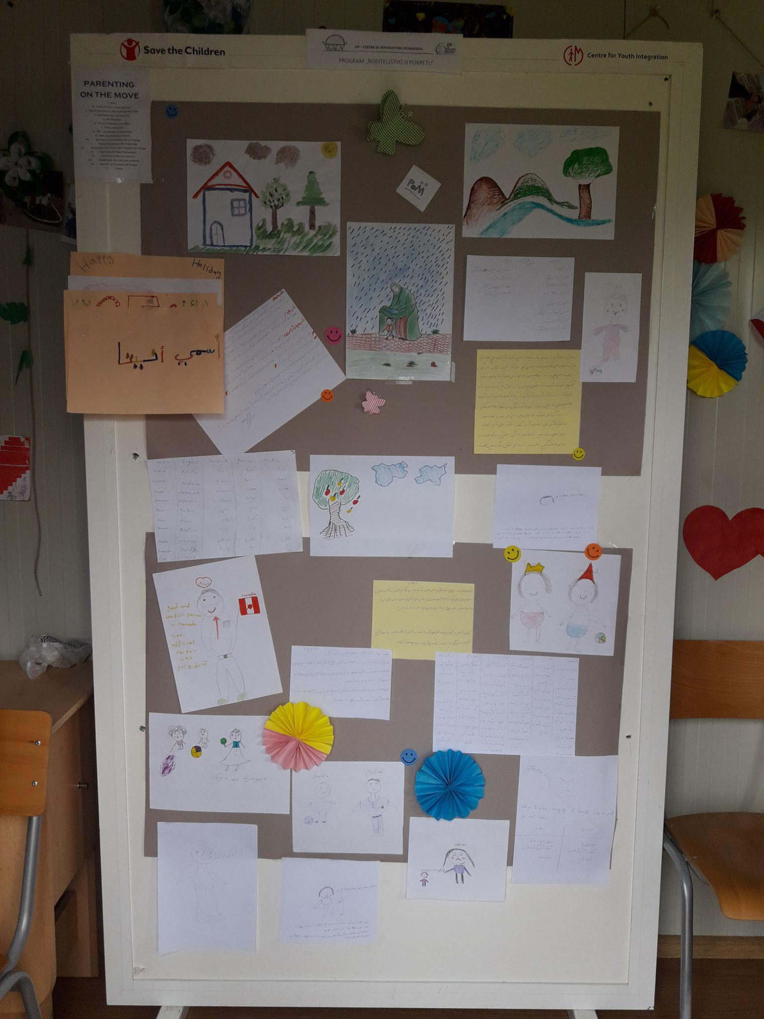
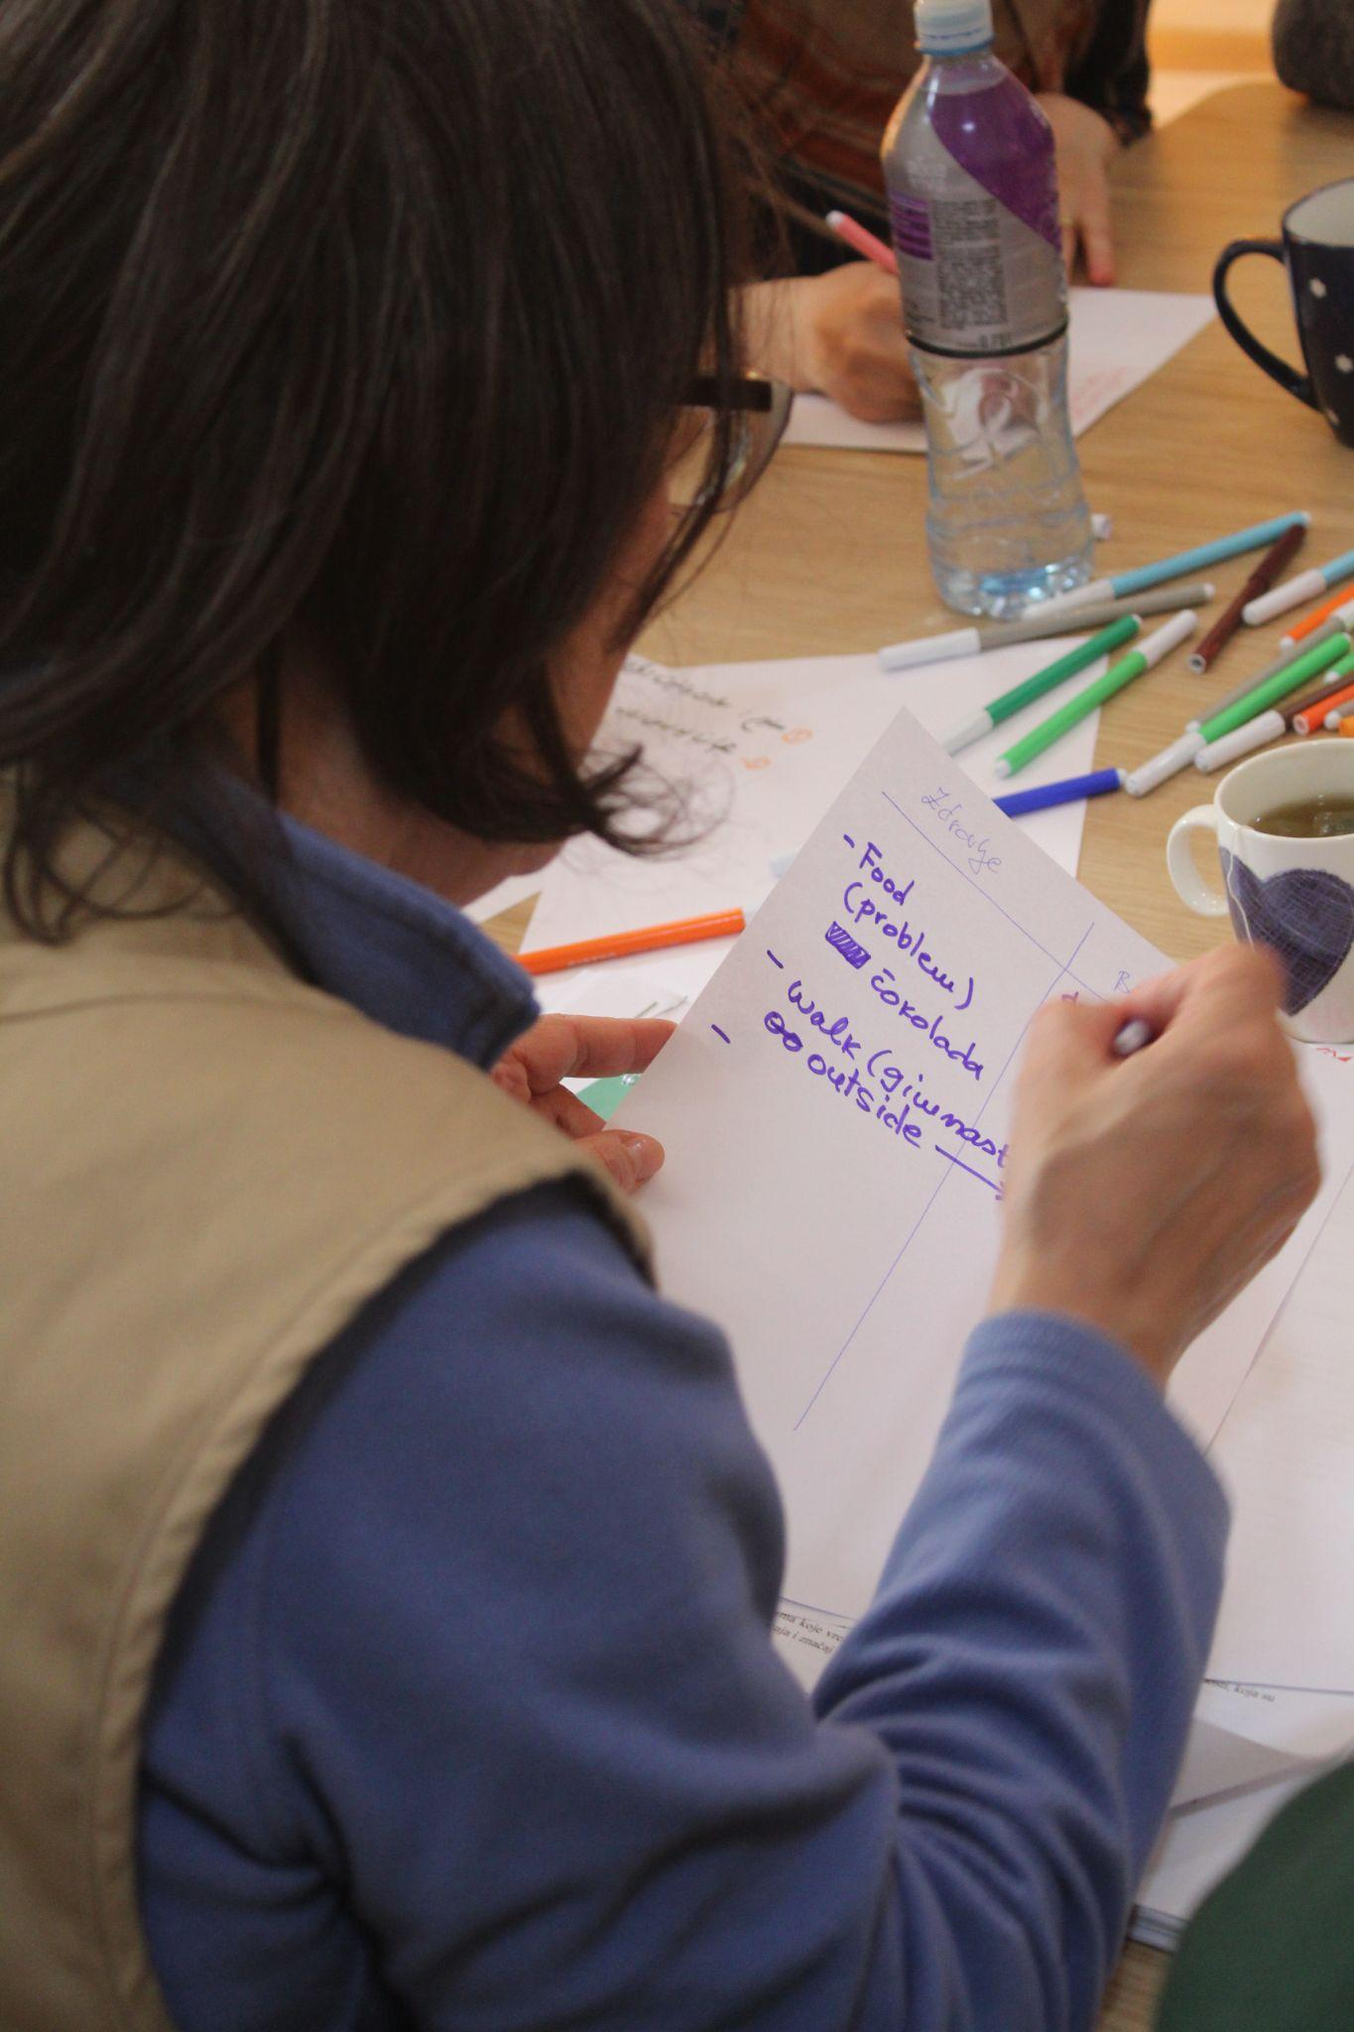
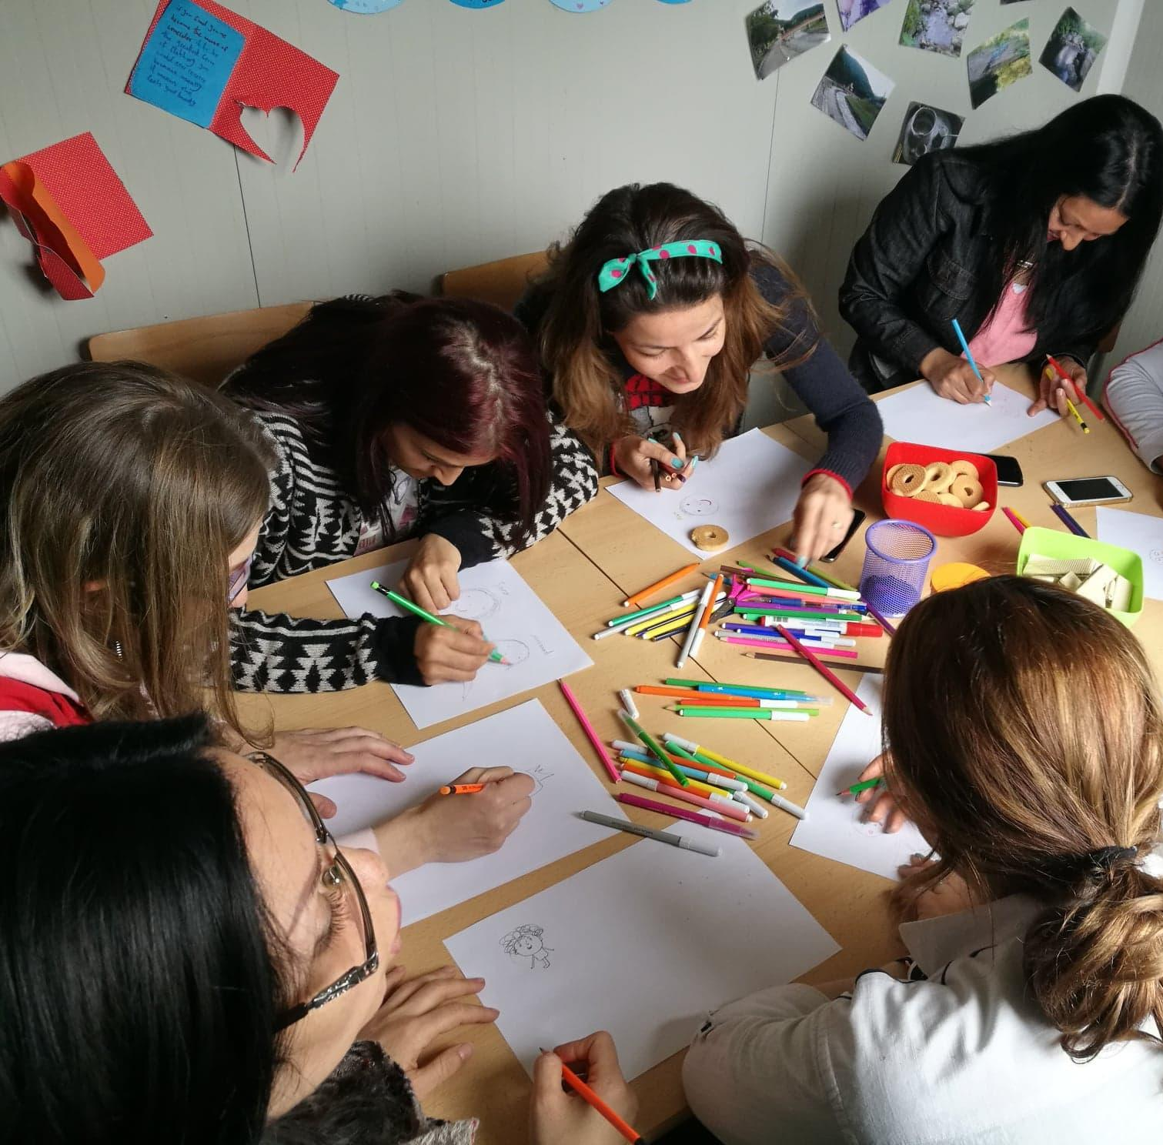

Measuring impact in time of crisis – Monitoring & Evaluation
Monitoring and Evaluation | War and Conflict | International Step by Step Association ISSA and members, International
What Happened?
Following the onset of the war in Ukraine, ISSA Members worked to ensure that early childhood interventions were not only delivered but also measured for impact. In several municipalities across Members’ countries, using the Primokiz methodology, local action teams implemented situation analyses, needs assessments, and participatory processes to capture the real effects of their crisis-response work with young children, parents, and practitioners.
What was needed? How did ISSA Members respond?
There was an urgent need for reliable, real-time data to understand how war, displacement, service disruption, and new interventions were affecting young children’s learning, well-being, and access to services.
ISSA Members responded by designing and conducting local situation analyses in municipalities, documenting service availability, capacity gaps, and family needs. In addition, training programs for ECD staff were paired with pre- and post-assessments to measure knowledge gains and inform follow-up support.
Key challenges:
- Inconsistent or missing local data on young children’s access to services.
- Limited capacity at municipal level to systematically collect and analyse feedback.
- The urgency of service delivery sometimes overshadowed reflection and analysis.
Solutions:
- Embedded monitoring tools in all major interventions, ensuring data was collected without delaying service delivery.
- Shared templates and methodologies across municipalities to make data collection more consistent.
- Provided support to local teams to collect data in a participatory way, interpret findings and feed them back into decision-making at the local level.
By sharing tools, templates, and analysis methods through the ISSA network, Members were able to improve consistency in local monitoring and adapt quickly to emerging needs. This fostered better-informed interventions and enabled some cross-country comparison. ISSA facilitated the exchange of monitoring methodologies among members, provided technical input for designing assessment tools, and supported the inclusion of findings into advocacy at both the municipal and national levels.
What’s in place? What’s missing?
Crisis-response monitoring in participating municipalities benefited from practical tools like pre- and post-assessments and in-depth situation analyses, which fed directly into service improvement. However, without a unified, crisis-specific monitoring framework at the national or cross-country level, data stayed local and varied in quality, limiting the potential for broader learning and systemic change.
Being part of a regional network: Advantages of ISSA membership
The introduction of Primokiz in Romania, through collaboration between ISSA, UNICEF, and local authorities, illustrates the advantages of belonging to a regional network. ISSA brings access to tested methodologies, international expertise, and peer exchange that help adapt global models to national contexts. This collaboration turned early childhood planning from a sector, based exercise into a coordinated and participatory process, ensuring that investments are directed where children and families need them most, and where alternative service models can make the greatest impact.
Recommendations
National Policymakers
National decision-makers should view the Primokiz methodology not as a temporary solution but as a strategic tool for rethinking early childhood services. In Romania, its implementation supported by UNICEF and in partnership with local authorities offered an alternative to the classic model of expanding nurseries or kindergartens. Instead, it emphasized cross-sectoral coordination between education, health, and social protection, while engaging communities in planning. Embedding this model into national policies would make services more flexible, locally adapted, and sustainable, reducing inequalities and diversifying the offer beyond traditional infrastructure.
Local/National Actors
At the local level, Primokiz has shown the power of participatory processes that bring together parents, professionals, and administrations to co-create early childhood strategies. In Romania, municipalities using the methodology identified not only shortages, such as a lack of places in nurseries, but also opportunities to better use existing resources like community centers, schools, or NGO networks. Local actors can leverage this framework to develop alternative services (play centers, parenting programs, targeted support for vulnerable families) that complement and enrich the classical provision of care.
Private Donors
Private donors have a key role in enabling innovation. Their support can fund situation analyses, training for local teams, and pilot initiatives that test new service models. In Romania, flexible donor support made it possible to adapt Primokiz to very different contexts, from large cities to rural communities, generating scalable models. For donors, investing in Primokiz means investing not only in infrastructure but also in the capacity of communities to design and sustain their own solutions for children and families.
Professionals/Practitioners
Teachers, health workers, and social service professionals were directly engaged in the Primokiz process through workshops, focus groups, and participatory assessments. Their involvement improved understanding of each sector’s role and led to practical joint solutions. For practitioners, Primokiz provides an opportunity to make their voices heard in local planning, to work in interdisciplinary teams, and to align interventions more closely with children’s and families’ real needs. This makes services more relevant, responsive, and anchored in everyday realities.
‘"Through the Primokiz process, we discovered that our community already had valuable resources, like cultural centers, that could be adapted to support young children. It changed how we think about planning services."
Mayor (Romania)
"For the first time, someone asked us directly what we needed for our children. I felt part of the solution, not just a beneficiary."
Parent (Romania)

Conclusion
This Compendium brings together lessons learned from across the ISSA network, covering Europe and Central Asia, capturing the diverse experiences and insights of members who have acted with resilience and innovation in times of crisis. It reflects how early childhood systems can adapt, recover, and rebuild when guided by strong collaboration, competent and supported workforces, and an unwavering focus on young children’s rights and well-being. The experiences presented here highlight how local action, when supported by strong systems and coordinated frameworks, can make the difference between disruption and resilience.
At the same time, this publication represents one step within a broader and ongoing process. The conversation on early childhood system preparedness extends far beyond Europe and Central Asia. Around the world, regional networks and organizations have been deeply engaged in responding to emergencies and have accumulated a wealth of experience and knowledge in this area. Recognizing and connecting with their work is essential to ensure that the collective understanding of what preparedness means for systems, for services, and for children, continues to evolve.
The Compendium therefore serves both as a reflection and as a bridge: it reflects what has been learned through the ISSA network’s journey, while also opening pathways for continued collaboration and dialogue with peers across regions. The goal is not only to share what worked within one context, but to contribute to a global process of strengthening early childhood systems so that they can anticipate, withstand, and recover from crises with greater coherence and equity.
In this spirit, this publication stands as an invitation to continue learning together, to draw from diverse regional strengths, and to ensure that the preparedness of early childhood systems remains a shared, living agenda. Ultimately, it is through collective wisdom and cooperation that we can build systems capable of protecting and nurturing every young child, everywhere, even in the most challenging times.

Appendix

Common Elements of Early Childhood System Preparedness Across Emergencies
The table below provides a cross-cutting overview of how the five core components of Early Childhood System Preparedness for Emergencies: Emergency Response, Flexible Service Delivery, Workforce Capacity and Well-being, Integrated MHPSS, and Governance, Coordination and Accountability, apply across different types of emergencies. These actions represent the foundational measures required in all crisis settings to ensure that young children and their caregivers continue to receive protection, care, and developmental support. While the context of each emergency may differ, these core principles remain constant and form the basis of resilient early childhood systems.

Component | Displacement | Natural Disaster | Pandemic | War & Conflict
Emergency Response | Provide safe shelter, health and nutrition support, and rapid family tracing systems. | Evacuate families safely, set up child-safe shelters, ensure urgent healthcare and sanitation. | Maintain essential health, nutrition, and caregiving services; support families with food and financial aid. | Ensure children’s physical safety; deliver emergency medical and psychosocial support; track and reunify separated children.
Flexible Service Delivery | Use mobile services and portable learning kits; maintain case management even when families move. | Provide temporary clinics and classrooms; use home or community-based learning resources. | Deliver remote or low-contact learning and support; continue outreach through safe visits or phone contact. | Use mobile health units and temporary learning spaces; rely on community networks to reach families.
Workforce Capacity & Well-being | Train staff in trauma-informed care and cultural sensitivity; support staff mental health. | Prepare staff for high-stress emergency environments and child protection in shelters. | Train for remote support, infection prevention, and social-emotional coaching for caregivers. | Support workers’ emotional health; train on protection and caregiving in high-risk and insecure environments.
Integrated Mental Health & Psychosocial Support (MHPSS) | Create safe play spaces, rebuild routines, support caregiver–child attachment, and address stigma. | Restore routines, provide safe spaces for play and emotional expression, and support caregivers’ stress and grief. | Provide caregiver support, rebuild peer interaction, and offer bereavement and emotional support. | Use play-based healing, trauma counselling, safe social connection, and caregiver support to mitigate stress and fear.
Governance, Coordination & Accountability | Coordinate across humanitarian and government systems; guarantee equal access regardless of legal status; monitor discrimination. | Coordinate health, education, and child protection actors; uphold standards for child-safe shelters; gather community feedback. | Coordinate health, education, and social protection systems; sustain core services; use data to track equity. | Maintain protection systems; prioritize access for displaced and marginalized families; use monitoring to ensure continuity and fairness.

Distinct Actions by Emergency Type
The second table highlights the context-specific adaptations required for each emergency type. Although the same five preparedness components apply across crises, the way they are implemented must respond to the unique stressors and operational challenges associated with displacement, natural disasters, pandemics, and conflict. This table therefore outlines the distinct strategies, service delivery adaptations, and workforce competencies needed to effectively support young children and caregivers in each emergency context. It shows where priorities shift, where additional considerations are needed, and how systems must adjust their approach while staying anchored in the common preparedness framework.

Component | Displacement | Natural Disaster | Pandemic | War & Conflict
Emergency Response | Flexible registration + temporary IDs; mobile health & nutrition; attachment-preserving interim care; anti-discrimination safeguards. | Pre-planned evacuation + child-safe shelters; mobile trauma teams; rapid tracing systems; Psychological First Aid. | Infection-sensitive tracing & interim care; emergency cash/food; adapted immunization & MNH; DV prevention + bereavement support. | Safe evacuation to protection-compliant shelters; medical + psychosocial first aid; robust tracing; emotional safety in all services.
Flexible Service Delivery | Mobile units that follow families; volunteer case-management; host-community food/voucher integration; inclusive neutral play spaces. | Temporary classrooms/clinics; caregiver-led learning + radio/digital; regular outreach to shelters/host families; mobile WASH & nutrition points. | Remote / low-contact support; hotlines & online groups; mobile vaccination; food delivery/vouchers; safe virtual/limited socialization options. | Mobile clinics & temporary learning in/near conflict zones; community-based monitoring; safe camp distribution; structured safe play despite insecurity.
Workforce Capacity & Well-being | Training on separation risks & malnutrition screening; trauma & discrimination awareness; education-in-emergencies; staff peer support + rest rotations. | Pediatric trauma + first aid; search-and-rescue coordination; shelter/WASH/child-friendly standards; Psychological First Aid + debriefing. | Identify separation risk; remote pedagogy + infection prevention; detect violence/neglect remotely; remote nutrition screening. | Identify unaccompanied children; safe work in insecure environments; low-resource trauma-informed teaching; psychological support for staff.
Integrated MHPSS | Attachment repair + caregiver support; coping tools for repeated relocation; anti-discrimination peer groups; MHPSS linked to food support. | Safe expression/play spaces; restore routines; group/cultural resilience activities; trauma care for severe anxiety/grief. | Caregiver stress & bereavement support; rebuild peer interaction via safe/virtual means; home-based routines for stability. | Grief support for children & caregivers; play as therapy; violence-prevention tools + caregiver groups; MHPSS addressing food insecurity stress.
Governance, Coordination & Accountability | Cross-border referral continuity; equal access regardless of documentation; displaced family/youth participation; real-time service tracking. | Standardized tracing & reunification; re-establish learning early; enforce child-safe shelter/building standards; child-sensitive feedback systems. | Align health–education–social protection; cash assistance linked to service access; safe reopening strategies; equity monitoring. | Whole-system coordination across actors; maintain protection services under insecurity; standards balancing security + developmental rights; prioritize marginalized families.



International Step by Step Association (ISSA)
Kinderrechtenhuis / Child Rights Home
Hooglandse Kerkgracht 17-R
2312 HS Leiden
the Netherlands
Tel: +31 (0)71 516 1222

International Step by Step Association (ISSA)
Kinderrechtenhuis / Child Rights Home
Hooglandse Kerkgracht 17-R
2312 HS Leiden
the Netherlands
Tel: +31 (0)71 516 1222

International Step by Step Association (ISSA)
Kinderrechtenhuis / Child Rights Home
Hooglandse Kerkgracht 17-R
2312 HS Leiden
the Netherlands
Tel: +31 (0)71 516 1222

International Step by Step Association (ISSA)
Kinderrechtenhuis / Child Rights Home
Hooglandse Kerkgracht 17-R
2312 HS Leiden
the Netherlands
Tel: +31 (0)71 516 1222

